UNITED STATES
SECURITIES AND EXCHANGE COMMISSION
Washington, D.C. 20549
FORM 6-K
REPORT OF FOREIGN PRIVATE ISSUER
PURSUANT TO RULE 13a-16 OR 15d-16
UNDER THE SECURITIES EXCHANGE ACT OF 1934
For the month of August, 2026
Commission File Number: 001-36815
Ascendis Pharma A/S
(Translation of registrant’s name into English)
Tuborg Boulevard 12
DK-2900 Hellerup
Denmark
(Address of principal executive offices)
Indicate by check mark whether the registrant files or will file annual reports under cover of Form 20-F or Form 40-F.
Form 20-F ☒ Form 40-F ☐

INCORPORATION BY REFERENCE
This report on Form 6-K shall be deemed to be incorporated by reference into the registration statements on Form S-8 (Registration Numbers 333-203040, 333-210810, 333-211512, 333-213412, 333-214843, 333-216883, 333-228576, 333-254101, 333-261550, 333-270088, 333-277519, 333-281916, 333-285322 and 333-293854) and Form F-3 (Registration Numbers 333-209336 and 333-282196) of Ascendis Pharma A/S (the “Company” or “Ascendis”) (including any prospectuses forming a part of such registration statements) and to be a part thereof from the date on which this report is filed, to the extent not superseded by documents or reports subsequently filed or furnished.
Information Contained in this Report on Form 6-K
Financial Statements
This report contains the Company’s Unaudited Condensed Consolidated Interim Financial Statements as of and for the period ended June 30, 2026, including Management’s Discussion and Analysis of Financial Condition and Results of Operations for the period presented therein.

SIGNATURE
Pursuant to the requirements of the Securities Exchange Act of 1934, as amended, the registrant has duly caused this report to be signed on its behalf by the undersigned hereunto duly authorized.
 |  | Ascendis Pharma A/S
Date: August 13, 2026 |  | By: | /s/ Michael Wolff Jensen
 |  |  | Michael Wolff Jensen
 |  |  | Executive Vice President, Chief Legal Officer

TABLE OF CONTENTS
1. | Unaudited Condensed Consolidated Interim Financial Statements – June 30, 2026 | F-1
2. | Management’s Discussion and Analysis of Financial Condition and Results of Operations | 1

ASCENDIS PHARMA A/S
INDEX TO UNAUDITED CONDENSED CONSOLIDATED INTERIM FINANCIAL STATEMENTS
 | Page
Unaudited Condensed Consolidated Interim Statements of Profit or (Loss) and Other Comprehensive Income or (Loss) for the Three and Six Months Ended June 30, 2026 and 2025 | F-2
Unaudited Condensed Consolidated Interim Statements of Financial Position as of June 30, 2026 and December 31, 2025 | F-3
Unaudited Condensed Consolidated Interim Statements of Changes in Equity for the Six Months Ended June 30, 2026 and 2025 | F-4
Unaudited Condensed Consolidated Interim Statements of Cash Flows for the Six Months Ended June 30, 2026 and 2025 | F-5
Notes to the Unaudited Condensed Consolidated Interim Financial Statements | F-6

F-1

Unaudited Condensed Consolidated Interim Statements of Profit or (Loss)
and Other Comprehensive Income or (Loss) for the Three and Six Months Ended June 30, 2026 and 2025
 |  |  |  | Three Months Ended  June 30, |  |  |  |  |  |  |  | Six Months Ended  June 30,
(EUR’000, except per share data) |  | Notes |  | 2026 |  |  |  | 2025 |  |  |  | 2026 |  |  |  | 2025
Consolidated Statement of Profit or (Loss)
Revenue |  | 5 |  |  | 339,285 |  |  |  | 158,045 |  |  |  | 585,886 |  |  |  | 258,998
Cost of sales |  |  |  |  | (27,658 | ) |  |  | (31,447 | ) |  |  | (45,173 | ) |  |  | (48,963 | )
Gross profit |  |  |  |  | 311,627 |  |  |  | 126,598 |  |  |  | 540,713 |  |  |  | 210,035
Research and development expenses |  |  |  |  | (75,888 | ) |  |  | (71,988 | ) |  |  | (134,932 | ) |  |  | (158,591 | )
Selling, general, and administrative expenses |  |  |  |  | (173,341 | ) |  |  | (107,561 | ) |  |  | (318,571 | ) |  |  | (208,608 | )
Other operating income |  | 4 |  |  | 158,067 |  |  |  | — |  |  |  | 158,067 |  |  |  | —
Operating profit/(loss) |  |  |  |  | 220,465 |  |  |  | (52,951 | ) |  |  | 245,277 |  |  |  | (157,164 | )
Share of profit/(loss) of associates |  |  |  |  | 3,836 |  |  |  | (4,097 | ) |  |  | (6,415 | ) |  |  | 22,482
Finance income |  |  |  |  | 19,965 |  |  |  | 55,059 |  |  |  | 9,347 |  |  |  | 83,912
Finance expenses |  |  |  |  | (14,173 | ) |  |  | (33,018 | ) |  |  | (66,292 | ) |  |  | (77,803 | )
Profit/(loss) before tax |  |  |  |  | 230,093 |  |  |  | (35,007 | ) |  |  | 181,917 |  |  |  | (128,573 | )
Income taxes (expenses) |  | 4 |  |  | (23,123 | ) |  |  | (3,848 | ) |  |  | 654,393 |  |  |  | (4,909 | )
Net profit/(loss) for the period |  |  |  |  | 206,970 |  |  |  | (38,855 | ) |  |  | 836,310 |  |  |  | (133,482 | )
Attributable to owners of the Company |  |  |  |  | 206,970 |  |  |  | (38,855 | ) |  |  | 836,310 |  |  |  | (133,482 | )
Basic earnings/(loss) per share |  | 6 |  |  | 3.22 |  |  |  | (0.64 | ) |  |  | 13.27 |  |  |  | (2.22 | )
Diluted earnings/(loss) per share |  | 6 |  |  | 2.83 |  |  |  | (0.82 | ) |  |  | 12.73 |  |  |  | (2.22 | )
Consolidated Statement of Comprehensive Income or (Loss)
Net profit/(loss) for the period |  |  |  |  | 206,970 |  |  |  | (38,855 | ) |  |  | 836,310 |  |  |  | (133,482 | )
Other comprehensive income/(loss)
Items that may be reclassified subsequently to profit or (loss):
Exchange differences on translating foreign operations |  |  |  |  | 4,859 |  |  |  | (1,399 | ) |  |  | 7,917 |  |  |  | (1,474 | )
Other comprehensive income/(loss) for the period, net of tax |  |  |  |  | 4,859 |  |  |  | (1,399 | ) |  |  | 7,917 |  |  |  | (1,474 | )
Total comprehensive income/(loss) for the period, net of tax |  |  |  |  | 211,829 |  |  |  | (40,254 | ) |  |  | 844,227 |  |  |  | (134,956 | )
Attributable to owners of the Company |  |  |  |  | 211,829 |  |  |  | (40,254 | ) |  |  | 844,227 |  |  |  | (134,956 | )

F-2

Unaudited Condensed Consolidated Interim Statements of Financial Position as of June 30, 2026 and December 31, 2025
(EUR’000) |  | Notes |  | June 30,  2026 |  |  |  | December 31,  2025
Assets
Non-current assets
Intangible assets |  |  |  |  | 3,680 |  |  |  | 3,710
Property, plant and equipment |  |  |  |  | 135,685 |  |  |  | 146,479
Investments in associates |  |  |  |  | 30,479 |  |  |  | 32,526
Other receivables |  | 11 |  |  | 26,489 |  |  |  | 10,870
Deferred tax assets |  | 4 |  |  | 699,276 |  |  |  | —
 |  |  |  |  | 895,609 |  |  |  | 193,585
Current assets
Inventories |  |  |  |  | 310,576 |  |  |  | 301,533
Trade receivables |  | 11 |  |  | 206,505 |  |  |  | 141,333
Income tax receivables |  |  |  |  | 1,993 |  |  |  | 1,781
Other receivables |  | 11 |  |  | 15,604 |  |  |  | 14,582
Prepayments |  |  |  |  | 43,473 |  |  |  | 33,715
Cash and cash equivalents |  | 11 |  |  | 812,260 |  |  |  | 616,041
 |  |  |  |  | 1,390,411 |  |  |  | 1,108,985
Total assets |  |  |  |  | 2,286,020 |  |  |  | 1,302,570
Equity and liabilities
Equity
Share capital |  | 9 |  |  | 8,885 |  |  |  | 8,322
Distributable equity |  |  |  |  | 1,427,606 |  |  |  | (171,143 | )
Total equity |  |  |  |  | 1,436,491 |  |  |  | (162,821 | )
Non-current liabilities
Borrowings |  | 11 |  |  | 384,642 |  |  |  | 385,254
Contract liabilities |  |  |  |  | — |  |  |  | 1,123
Deferred tax liabilities |  | 4 |  |  | — |  |  |  | 9,623
 |  |  |  |  | 384,642 |  |  |  | 396,000
Current liabilities
Convertible notes
Borrowings |  | 4, 11 |  |  | — |  |  |  | 429,391
Derivative liabilities |  | 4, 11 |  |  | — |  |  |  | 256,231
 |  |  |  |  | — |  |  |  | 685,622
Other current liabilities
Borrowings |  | 11 |  |  | 65,432 |  |  |  | 57,141
Contract liabilities |  |  |  |  | 2,776 |  |  |  | 4,944
Trade payables and accrued expenses |  | 11 |  |  | 103,920 |  |  |  | 90,657
Other liabilities |  | 11 |  |  | 58,690 |  |  |  | 58,204
Income tax payables |  |  |  |  | 12,662 |  |  |  | 6,427
Provisions |  |  |  |  | 221,407 |  |  |  | 166,396
 |  |  |  |  | 464,887 |  |  |  | 383,769
 |  |  |  |  | 464,887 |  |  |  | 1,069,391
Total liabilities |  |  |  |  | 849,529 |  |  |  | 1,465,391
Total equity and liabilities |  |  |  |  | 2,286,020 |  |  |  | 1,302,570

F-3

Unaudited Condensed Consolidated Interim Statements of Changes in Equity for the Six Months Ended June 30, 2026 and 2025
 |  |  |  |  |  |  |  | Distributable Equity
(EUR’000) |  | Notes |  | Share  Capital |  |  |  | Share  Premium |  |  |  | Treasury  Shares |  |  |  | Foreign  Currency  Translation  Reserve |  |  |  | Accumulated  Deficit |  |  |  | Total
Equity as of January 1, 2026 |  |  |  |  | 8,322 |  |  |  | 2,531,080 |  |  |  | (80 | ) |  |  | (1,755 | ) |  |  | (2,700,388 | ) |  |  | (162,821 | )
Net profit/(loss) for the period |  |  |  |  | — |  |  |  | — |  |  |  | — |  |  |  | — |  |  |  | 836,310 |  |  |  | 836,310
Other comprehensive income/(loss), net of tax |  |  |  |  | — |  |  |  | — |  |  |  | — |  |  |  | 7,917 |  |  |  | — |  |  |  | 7,917
Total comprehensive income/(loss) |  |  |  |  | — |  |  |  | — |  |  |  | — |  |  |  | 7,917 |  |  |  | 836,310 |  |  |  | 844,227
Transactions with Owners
Share-based payment |  | 8 |  |  | — |  |  |  | — |  |  |  | — |  |  |  | — |  |  |  | 59,964 |  |  |  | 59,964
Income tax on equity transactions |  | 4 |  |  | — |  |  |  | — |  |  |  | — |  |  |  | — |  |  |  | 41,835 |  |  |  | 41,835
Acquisition of treasury shares |  | 10 |  |  | — |  |  |  | — |  |  |  | (68 | ) |  |  | — |  |  |  | (103,344 | ) |  |  | (103,412 | )
Transfer under stock incentive programs |  | 10 |  |  | — |  |  |  | — |  |  |  | 79 |  |  |  | — |  |  |  | (79 | ) |  |  | —
Net settlement under stock incentive programs |  |  |  |  | — |  |  |  | — |  |  |  | — |  |  |  | — |  |  |  | (12,781 | ) |  |  | (12,781 | )
Capital increase from exercise of warrants |  | 9 |  |  | 76 |  |  |  | 50,010 |  |  |  | — |  |  |  | — |  |  |  | — |  |  |  | 50,086
Capital increase from redemption of convertible notes |  | 4, 9 |  |  | 487 |  |  |  | 719,031 |  |  |  | — |  |  |  | — |  |  |  | — |  |  |  | 719,518
Cost of capital increase |  |  |  |  | — |  |  |  | (125 | ) |  |  | — |  |  |  | — |  |  |  | — |  |  |  | (125 | )
Equity as of June 30, 2026 |  |  |  |  | 8,885 |  |  |  | 3,299,996 |  |  |  | (69 | ) |  |  | 6,162 |  |  |  | (1,878,483 | ) |  |  | 1,436,491

 |  |  |  |  |  |  |  | Distributable Equity
(EUR’000) |  | Notes |  | Share  Capital |  |  |  | Share  Premium |  |  |  | Treasury  Shares |  |  |  | Foreign  Currency  Translation  Reserve |  |  |  | Accumulated  Deficit |  |  |  | Total
Equity as of January 1, 2025 |  |  |  |  | 8,149 |  |  |  | 2,444,175 |  |  |  | (113 | ) |  |  | 1,783 |  |  |  | (2,559,700 | ) |  |  | (105,706 | )
Net profit/(loss) for the period |  |  |  |  | — |  |  |  | — |  |  |  | — |  |  |  | — |  |  |  | (133,482 | ) |  |  | (133,482 | )
Other comprehensive income/(loss), net of tax |  |  |  |  | — |  |  |  | — |  |  |  | — |  |  |  | (1,474 | ) |  |  | — |  |  |  | (1,474 | )
Total comprehensive income/(loss) |  |  |  |  | — |  |  |  | — |  |  |  | — |  |  |  | (1,474 | ) |  |  | (133,482 | ) |  |  | (134,956 | )
Transactions with Owners
Share-based payment |  | 8 |  |  | — |  |  |  | — |  |  |  | — |  |  |  | — |  |  |  | 55,580 |  |  |  | 55,580
Acquisition of treasury shares |  |  |  |  | — |  |  |  | — |  |  |  | (16 | ) |  |  | — |  |  |  | (17,380 | ) |  |  | (17,396 | )
Transfer under stock incentive programs |  |  |  |  | — |  |  |  | — |  |  |  | 49 |  |  |  | — |  |  |  | (49 | ) |  |  | —
Net settlement under stock incentive programs |  |  |  |  | — |  |  |  | — |  |  |  | — |  |  |  | — |  |  |  | (11,396 | ) |  |  | (11,396 | )
Capital increase from exercise of warrants |  |  |  |  | 62 |  |  |  | 26,240 |  |  |  | — |  |  |  | — |  |  |  | — |  |  |  | 26,302
Equity as of June 30, 2025 |  |  |  |  | 8,211 |  |  |  | 2,470,415 |  |  |  | (80 | ) |  |  | 309 |  |  |  | (2,666,427 | ) |  |  | (187,572 | )
F-4

Unaudited Condensed Consolidated Interim Statements of Cash Flows for the Six Months Ended June 30, 2026 and 2025
Six Months Ended
June 30,
(EUR’000) |  | 2026 |  |  |  | 2025
Operating activities
Net profit/(loss) for the period |  |  | 836,310 |  |  |  | (133,482 | )
Reversal of finance income |  |  | (9,347 | ) |  |  | (83,912 | )
Reversal of finance expenses |  |  | 66,292 |  |  |  | 77,803
Reversal of (gain)/loss on disposal of property, plant and equipment |  |  | 21 |  |  |  | —
Reversal of income taxes |  |  | (654,393 | ) |  |  | 4,909
Adjustments for non-cash items:
Non-cash consideration relating to revenue |  |  | (3,112 | ) |  |  | (2,214 | )
Share of (profit)/loss of associates |  |  | 6,415 |  |  |  | (22,482 | )
Share-based payment |  |  | 59,964 |  |  |  | 55,580
Depreciation and amortization |  |  | 8,789 |  |  |  | 8,853
Impairment of property, plant and equipment |  |  | — |  |  |  | 7,508
Changes in working capital:
Inventories |  |  | (9,044 | ) |  |  | (7,772 | )
Receivables |  |  | (61,050 | ) |  |  | 50,047
Prepayments |  |  | (9,487 | ) |  |  | (6,801 | )
Contract liabilities |  |  | (3,291 | ) |  |  | (3,455 | )
Trade payables, accrued expenses and other liabilities |  |  | 8,659 |  |  |  | (25,558 | )
Provisions |  |  | 50,369 |  |  |  | 65,536
Cash flows generated from/(used in) operations |  |  | 287,095 |  |  |  | (15,440 | )
Finance income received |  |  | 9,347 |  |  |  | 7,603
Finance expenses paid |  |  | (17,115 | ) |  |  | (9,689 | )
Income taxes received/(paid) |  |  | (5,366 | ) |  |  | (4,128 | )
Cash flows from/(used in) operating activities |  |  | 273,961 |  |  |  | (21,654 | )
Investing activities
Payments received under finance leases |  |  | 1,341 |  |  |  | —
Acquisition of intangible assets and property, plant and equipment |  |  | (10,948 | ) |  |  | (5,041 | )
Cash flows from/(used in) investing activities |  |  | (9,607 | ) |  |  | (5,041 | )
Financing activities
Repayment of borrowings |  |  | (16,720 | ) |  |  | (8,553 | )
Proceeds from exercise of warrants |  |  | 50,086 |  |  |  | 26,302
Costs of capital increase |  |  | (125 | ) |  |  | —
Acquisition of treasury shares |  |  | (103,412 | ) |  |  | (17,396 | )
Payment of withholding taxes under stock incentive programs |  |  | (12,781 | ) |  |  | (11,396 | )
Cash flows from/(used in) financing activities |  |  | (82,952 | ) |  |  | (11,043 | )
Increase/(decrease) in cash and cash equivalents |  |  | 181,402 |  |  |  | (37,738 | )
Cash and cash equivalents at January 1 |  |  | 616,041 |  |  |  | 559,543
Effect of exchange rate changes on balances held in foreign currencies |  |  | 14,817 |  |  |  | (27,759 | )
Cash and cash equivalents at June 30 |  |  | 812,260 |  |  |  | 494,046

F-5

Notes to the Unaudited Condensed Consolidated Interim Financial Statements
Note 1—General Information
Ascendis Pharma A/S, together with its subsidiaries, is a global biopharmaceutical company focused on applying its innovative TransCon technology platform to make a meaningful difference for patients. Ascendis Pharma A/S was incorporated in 2006 and is headquartered in Hellerup, Denmark. Unless the context otherwise requires, references to the “Company,” “we,” “us,” and “our” refer to Ascendis Pharma A/S and its subsidiaries.
The address of the Company’s registered office is Tuborg Boulevard 12, DK-2900, Hellerup, Denmark. The Company’s registration number in Denmark is 29918791.
On February 2, 2015, the Company completed an initial public offering which resulted in the listing of American Depositary Shares (“ADSs”), representing the Company’s ordinary shares, under the symbol “ASND” in the United States on the Nasdaq Global Select Market. On April 20, 2026, the Company completed a mandatory exchange of all outstanding ADSs for ordinary shares resulting in the Company’s ordinary shares being listed on the Nasdaq Global Select Market. Refer to Note 4, “Significant Events in the Reporting Period” for further details.
The Company’s Board of Directors (the “Board”) approved these unaudited condensed consolidated interim financial statements on August 12, 2026.
Note 2—Summary of Material Accounting Policies
Basis of Preparation
The unaudited condensed consolidated interim financial statements of the Company are prepared in accordance with International Accounting Standard 34, “Interim Financial Reporting.” Certain information and disclosures normally included in the annual consolidated financial statements prepared in accordance with IFRS Accounting Standards (“IFRS”) have been condensed or omitted. Accordingly, these unaudited condensed consolidated interim financial statements should be read in conjunction with the Company’s audited annual consolidated financial statements for the year ended December 31, 2025 and accompanying notes, which have been prepared in accordance with IFRS as issued by the International Accounting Standards Board (the “IASB”) and as adopted by the European Union (the “EU”).
The accounting policies applied are consistent with those of the previous financial year. A description of the accounting policies is provided in the Accounting Policies section of the audited consolidated financial statements as of and for the year ended December 31, 2025.
New and Amended IFRS Accounting Standards and Interpretations
In May 2024, the IASB issued Amendments to the Classification and Measurement of Financial Instruments which amended IFRS 9 “Financial Instruments” and IFRS 7 “Financial Instruments: Disclosures” (the “Amendments”). The Amendments provide additional guidance and clarity on specific matters following completion of the IFRS 9 post-implementation review for Classification and Measurement. The Amendments apply for the annual reporting periods beginning on or after January 1, 2026. The Amendments:
•
clarify the existing requirements for the recognition and derecognition of financial assets and financial liabilities, including an accounting policy choice to derecognize financial liabilities settled using an electronic payment system before the settlement date.
•
provide guidance on assessing whether the contractual cash flows of a financial asset are solely payments of principal and interest (“SPPI”), including instruments with environmental, social and corporate governance (“ESG”)-linked or other contingent features.
•
clarify the treatment of non-recourse assets and contractually linked instruments (“CLI”), including how to assess SPPI and apply the CLI requirements.
•
require additional disclosures for instruments with contingent contractual terms, and for equity instruments classified at fair value through other comprehensive income.
The Company has assessed this amendment and concluded that this, and other new and amended standards and interpretations applied for the first time in 2026, did not have an impact on its operations or unaudited condensed consolidated interim financial statements for the period ended June 30, 2026.
F-6

New IFRS Accounting Standards Not Yet Effective
The IASB has issued a number of new or amended standards, which have not yet become effective or have not yet been adopted by the EU. Therefore, these new standards have not been incorporated in these unaudited condensed consolidated interim financial statements.
IFRS 18, “Presentation and Disclosure in Financial Statements”
In April 2024, the IASB issued IFRS 18, “Presentation and Disclosure in Financial Statements” (“IFRS 18”), which replaces IAS 1, “Presentation of Financial Statements.” IFRS 18 introduces new categories and subtotals in the statement of profit or loss, comprising the following categories:
•
Operating activities;
•
Investing activities;
•
Financing activities;
•
Income taxes; and
•
Discontinued operations.
In addition, IFRS 18 includes new requirements for the location, aggregation and disaggregation of financial information, and disclosure of management-defined performance measures, as defined, if any. IFRS 18 does not include any measurement changes.
IFRS 18 will be effective for annual reporting periods beginning on or after January 1, 2027, and must be applied retrospectively, with early adoption permitted. While IFRS 18 will change the structure and subtotals in the statement of profit or loss, the full impact from implementing IFRS 18 is currently being analyzed.
The unaudited condensed consolidated interim financial statements are not expected to be affected by other new or amended standards.
Note 3—Significant Accounting Judgments and Estimates
In the application of the Company’s accounting policies, management is required to make judgments, estimates and assumptions about the carrying amounts of assets and liabilities that are not readily apparent from other sources. Judgments, estimates and assumptions applied are based on historical experience and other factors that are relevant, and which are available at the reporting date. Uncertainty concerning estimates and assumptions could result in outcomes that require a material adjustment to assets and liabilities in future periods.
The unaudited condensed consolidated interim financial statements do not include all disclosures for significant accounting judgments, estimates and assumptions, that are required in the annual consolidated financial statements, and therefore should be read in conjunction with the Company’s audited consolidated financial statements as of and for the year ended December 31, 2025.
Estimates and underlying assumptions are reviewed on an ongoing basis. Revisions to accounting estimates are recognized prospectively. The three and six months ended June 30, 2026 and 2025 include adjustments to prior-period estimates and assumptions for sales deductions.
While the application of critical accounting estimates is subject to material estimation uncertainties, management’s ongoing revisions of critical accounting estimates and underlying assumptions have, except for deferred tax assets, as described below, not revealed any other material impact to any of the periods presented in the unaudited condensed consolidated interim financial statements compared to December 31, 2025.
Deferred Tax Assets
As of June 30, 2026, the Company has recognized all deferred tax assets. Deferred tax assets are recognized only to the extent that management assesses it is probable that future taxable profits will be available against which these assets can be utilized. This assessment involves significant judgment and is reviewed on an ongoing basis, considering actual results as well as updated forecasts and long-range business plans.
Key sources of estimation uncertainty primarily relate to continued global commercial growth, mainly expected revenue growth from YORVIPATH, and development of operating expenses to support growth.
F-7

As of June 30, 2026, recognized deferred tax assets were €699.3 million. The basis for recognizing deferred tax assets will be reassessed annually, or more frequently considering internal and external factors that may affect the Company’s ability to generate taxable profits, and adjusted as necessary. Due to the nature of factors affecting taxable profit, it is not practicable to provide meaningful sensitivity analyses. Refer to Note 4, “Significant Events in the Reporting Period” for further details about the impact on the unaudited condensed consolidated interim statements.
Note 4—Significant Events in the Reporting Period
Redemption of $575 Million of Outstanding 2.25% Convertible Notes
On May 6, 2026, the Company completed its previously announced optional redemption process in respect of all of the aggregate principal amount outstanding of its 2.25% convertible notes due 2028. Within the redemption period, all holders of the convertible notes surrendered their notes for conversion, whereupon the Company delivered 3,635,813 ordinary shares, together with cash in lieu of fractional shares.
The conversion resulted in the settlement of the current liabilities of convertible notes, comprising borrowings and derivative liabilities totaling €719.4 million as of May 6, 2026. The conversion had no impact on profit or loss.
U.S. Regulatory Approval of YUVIWEL® (navepegritide; developed as TransCon® CNP)
On February 27, 2026, the Company announced that the U.S. Food & Drug Administration (“FDA”) has granted approval under the FDA’s Accelerated Approval Program for YUVIWEL® (navepegritide; developed as TransCon® CNP), the first and only once-weekly treatment indicated to increase linear growth in children 2 years of age and older with achondroplasia with open epiphyses and the only one to provide continuous systemic exposure to C-type natriuretic peptide (“CNP”) over the weekly dosing interval.
Inventory
As a result of obtaining marketing approval for YUVIWEL, the Company reversed prior period write-downs related to pre-launch inventories through research and development expenses. For the six months ended June 30, 2026, the reversal had a positive impact of €10.9 million on the Company’s unaudited condensed consolidated interim statement of profit or loss.
Rare Pediatric Disease Priority Review Voucher (“PRV”)
With the approval, the FDA issued a Rare Pediatric Disease PRV, which confers priority review to a subsequent drug application that would not otherwise qualify for priority review.
On May 6, 2026, the Company entered into an agreement to sell its Rare Pediatric Disease PRV to an undisclosed buyer for $187.5 million. The PRV was awarded by the FDA upon approval of YUVIWEL in February 2026. The transaction closed with payment in the second quarter of 2026. The income from sale of the PRV, net of transaction costs was €158.1 million and is presented as other operating income in the statements of profit or loss and included within cash flows from operating activities in the statements of cash flows, since it arises from the Company’s R&D and regulatory activities.
Nasdaq Listing of Ordinary Shares
On April 20, 2026, the Company completed a mandatory exchange of all outstanding ADSs for ordinary shares, resulting in the Company’s ordinary shares being listed on the Nasdaq Global Select Market.
The direct listing and the exchange of ADSs for ordinary shares did not have any impact on the Company’s consolidated financial statements other than presentational changes reflecting the elimination of the ADS structure and corresponding updates to the related disclosures regarding share-based payment arrangements and convertible notes.
Share Repurchase Program
On January 9, 2026, the Company announced that the Board had authorized a $120 million share repurchase program (the “Share Repurchase Program”).
In March 2026, the Company repurchased 254,027 of its ordinary shares for a total consideration of $60.0 million with an average price of $236.16 under the Share Repurchase Program. In May 2026, the Company repurchased an additional 251,391 of its ordinary shares for a total consideration of $60.0 million with an average price of $238.64 under the same Program. The repurchased shares are held by the Company as treasury shares and presented as a deduction within equity.
F-8

The holding of treasury shares is disclosed in Note 10, “Treasury Shares.”
As of June 30, 2026, the Board is authorized by the shareholders to repurchase up to 2,000,000 of the Company’s ordinary shares.
Deferred Tax Assets
The Company has recognized deferred tax assets relating to tax losses carried forward and other deductible temporary differences. Deferred tax assets are recognized only to the extent that management assesses it is probable that future taxable profits will be available against which these assets can be utilized. Refer to Note 3, “Significant Accounting Judgments and Estimates” for further details. The deferred tax assets related to future use of tax losses can be carried forward without timing limitations.
Income taxes are recognized in the unaudited condensed consolidated interim statements of profit or loss with the following amounts:
 |  | Three Months Ended  June 30, |  |  |  |  |  |  |  | Six Months Ended  June 30,
(EUR’000) |  | 2026 |  |  |  | 2025 |  |  |  | 2026 |  |  |  | 2025
Tax on profit/(loss) for the period
Current tax (expense)/income |  |  | (2,296 | ) |  |  | (1,986 | ) |  |  | (3,583 | ) |  |  | (2,580 | )
Current tax, adjustments to prior periods |  |  | (9,202 | ) |  |  | — |  |  |  | (9,423 | ) |  |  | 9
Deferred tax, movement for the period |  |  | (36,247 | ) |  |  | (1,862 | ) |  |  | (36,810 | ) |  |  | (2,338 | )
Deferred tax, recognition of previously unrecognized deferred tax assets |  |  | — |  |  |  | — |  |  |  | 679,587 |  |  |  | —
Deferred tax, adjustments to prior periods |  |  | 24,622 |  |  |  | — |  |  |  | 24,622 |  |  |  | —
Total tax on profit/(loss) for the period |  |  | (23,123 | ) |  |  | (3,848 | ) |  |  | 654,393 |  |  |  | (4,909 | )
The development in deferred tax assets/(liabilities) was as follows:
(EUR’000) |  | 2026
Development in deferred tax assets/(liabilities)
January 1 |  |  | (9,623 | )
Deferred income tax (expense)/income, through profit or loss |  |  | 667,399
Deferred income tax (expense)/income, through equity |  |  | 40,632
Foreign exchange translation |  |  | 868
June 30 |  |  | 699,276
Classified in the statement of financial position
Deferred tax assets |  |  | 699,276
Deferred tax liabilities |  |  | —
Total deferred tax assets/(liabilities) at June 30 |  |  | 699,276
Specification of deferred tax assets/(liabilities) as of June 30, 2026 compared to December 31, 2025 was as follows:
(EUR’000) |  | June 30, 2026 |  |  |  | December 31, 2025
Deferred tax assets/(liabilities)
Tax deductible losses |  |  | 444,336 |  |  |  | 430,011
Other temporary differences, assets |  |  | 254,940 |  |  |  | 291,759
Deferred tax assets, not recognized |  |  | — |  |  |  | (721,631 | )
Other temporary differences, liabilities |  |  | — |  |  |  | (9,762 | )
Total deferred tax assets/(liabilities) |  |  | 699,276 |  |  |  | (9,623 | )

F-9

Note 5—Revenue
Revenue has been recognized in the unaudited condensed consolidated interim statements of profit or loss with the following amounts:
 |  | Three Months Ended  June 30, |  |  |  |  |  |  |  | Six Months Ended  June 30,
(EUR’000) |  | 2026 |  |  |  | 2025 |  |  |  | 2026 |  |  |  | 2025
Revenue
Commercial products |  |  | 314,910 |  |  |  | 153,663 |  |  |  | 555,763 |  |  |  | 249,690
Services and clinical supply |  |  | 4,856 |  |  |  | 3,570 |  |  |  | 9,965 |  |  |  | 7,094
Licenses |  |  | 2,473 |  |  |  | 812 |  |  |  | 3,112 |  |  |  | 2,214
Milestones |  |  | 17,046 |  |  |  | — |  |  |  | 17,046 |  |  |  | —
Total revenue |  |  | 339,285 |  |  |  | 158,045 |  |  |  | 585,886 |  |  |  | 258,998
Specified per geographical area
United States (1) |  |  | 265,471 |  |  |  | 108,344 |  |  |  | 474,548 |  |  |  | 181,976
Europe (2) |  |  | 49,671 |  |  |  | 27,894 |  |  |  | 85,989 |  |  |  | 49,222
Rest of World (1) |  |  | 24,143 |  |  |  | 21,807 |  |  |  | 25,349 |  |  |  | 27,800
Total revenue |  |  | 339,285 |  |  |  | 158,045 |  |  |  | 585,886 |  |  |  | 258,998
(1)
Beginning with the year ended December 31, 2025, revenue related to the United States has been disclosed separately. Comparatives for the United States and Rest of World have been restated for comparative purposes.
(2)
For the three and six months ended June 30, 2026, Denmark, the country of domicile, contributed €3.6 million and €8.1 million, respectively, of revenue. For the three and six months ended June 30, 2025, Denmark contributed €2.6 million and €5.0 million, respectively, of revenue.
Commercial Products
Revenue from sale of commercial products was as follows:
 |  | Three Months Ended  June 30, |  |  |  |  |  |  |  | Six Months Ended  June 30,
(EUR’000) |  | 2026 |  |  |  | 2025 |  |  |  | 2026 |  |  |  | 2025
Revenue from commercial products
YORVIPATH® |  |  | 252,114 |  |  |  | 102,957 |  |  |  | 449,010 |  |  |  | 147,646
SKYTROFA® |  |  | 55,214 |  |  |  | 50,706 |  |  |  | 99,171 |  |  |  | 102,044
YUVIWEL® |  |  | 7,582 |  |  |  | — |  |  |  | 7,582 |  |  |  | —
Total revenue from commercial products |  |  | 314,910 |  |  |  | 153,663 |  |  |  | 555,763 |  |  |  | 249,690
In the U.S., the Company has established an integrated organization to commercialize the Company’s approved Endocrinology Rare Disease products, YORVIPATH®, SKYTROFA® and YUVIWEL®. In Europe, the Company has established its presence by building integrated organizations in select countries (“Europe Direct”), where the Company has launched YORVIPATH and SKYTROFA.
Beyond the U.S. and Europe Direct, the Company is expanding global reach for its Endocrinology Rare Disease products through exclusive sales and distribution agreements with geographic market leaders (“International Markets”) and under Strategic Collaborations. As of June 30, 2026, the Company has agreements covering over 75 countries.
YORVIPATH, SKYTROFA and YUVIWEL are approved by the U.S. Food & Drug Administration (“FDA”) and YORVIPATH and SKYTROFA are authorized by the European Commission (“EC”) and other regulatory agencies. The Company began selling YUVIWEL in the U.S. in the second quarter of 2026. The Company began selling YORVIPATH in Europe in the first quarter of 2024 and in the U.S. in the fourth quarter of 2024. The Company began selling SKYTROFA in the U.S. in the fourth quarter of 2021 and in Europe in the third quarter of 2023.
Other Revenue
Other revenue is attributable to the Company’s Strategic Collaborations, and relates to Novo Nordisk A/S (“Novo Nordisk”), Eyconis, Inc. (“Eyconis”), Teijin Limited (“Teijin”) and VISEN Pharmaceuticals (“VISEN”).
F-10

Note 6—Earnings Per Share
The following table reflects the earnings and share data used in the basic and diluted earnings per share calculations:
 |  | Three Months Ended  June 30, |  |  |  |  |  |  |  | Six Months Ended  June 30,
(EUR’000, except number of shares and per share data) |  | 2026 |  |  |  | 2025 |  |  |  | 2026 |  |  |  | 2025
Earnings
Net profit/(loss) attributable to ordinary equity holders of the parent for the purposes of basic earnings per share |  |  | 206,970 |  |  |  | (38,855 | ) |  |  | 836,310 |  |  |  | (133,482 | )
Impact from convertible notes (interests, foreign exchange gain/(loss), and fair value adjustments on derivative liabilities, net of tax) |  |  | (13,770 | ) |  |  | (13,495 | ) |  |  | — |  |  |  | —
Net profit/(loss) attributable to ordinary equity holders of the parent adjusted for dilution effects |  |  | 193,200 |  |  |  | (52,350 | ) |  |  | 836,310 |  |  |  | (133,482 | )
Number of shares
Weighted average number of ordinary shares for the purposes of basic earnings per share |  |  | 64,344,993 |  |  |  | 60,454,589 |  |  |  | 63,011,704 |  |  |  | 60,237,774
Dilution effects from:
Convertible notes |  |  | 1,291,546 |  |  |  | 3,456,785 |  |  |  | — |  |  |  | —
Warrants and RSUs |  |  | 2,683,873 |  |  |  | — |  |  |  | 2,666,541 |  |  |  | —
Weighted average number of ordinary shares, diluted earnings per share |  |  | 68,320,412 |  |  |  | 63,911,374 |  |  |  | 65,678,245 |  |  |  | 60,237,774
Basic earnings per share |  | € | 3.22 |  |  | € | (0.64 | ) |  | € | 13.27 |  |  | € | (2.22 | )
Diluted earnings per share (1) |  | € | 2.83 |  |  | € | (0.82 | ) |  | € | 12.73 |  |  | € | (2.22 | )
(1)
For the three and six months ended June 30, 2026 and 2025 outstanding warrants, restricted stock units and performance stock units can potentially dilute earnings per share. For the three and six months ended June 30, 2026, only a portion were dilutive, while the remaining were excluded because they are out-of-the money and/or anti-dilutive for the periods presented. For the three and six months ended June 30, 2025, none had a dilutive impact. Refer to Note 8, “Share-based Payment” and Note 11, “Financial Assets and Liabilities,” for further information about the share-based incentive programs and convertible notes, respectively.
Note 7—Segment Information
The Company is managed and operated as one business unit. Accordingly, no additional information on business segments or geographical areas is disclosed apart from revenue by geographical areas as disclosed in Note 5 “Revenue.” Revenue is specified on geographical areas according to the location of the customer.
Note 8—Share-based Payment
As an incentive to the senior management, other employees, members of the Board and select consultants, Ascendis Pharma A/S has established warrant programs, a Restricted Stock Unit (“RSU”) program adopted in December 2021, and a Performance Stock Unit (“PSU”) program adopted in February 2023, which are all classified as equity-settled share-based payment transactions.
Share-based Compensation Costs
Share-based compensation costs are determined using the grant date fair value and are recognized over the vesting period as research and development expenses, selling, general and administrative expenses, or cost of sales. For the three and six months ended June 30, 2026 and 2025, share-based compensation costs recognized in the unaudited condensed consolidated interim statement of profit or loss were €29.6 million and €60.0 million, respectively, and €30.0 million and €55.6 million, respectively.
Restricted Stock Unit Program
RSUs are granted by the Board to members of senior management, other employees and members of the Board (the “RSU-holders”), as stipulated in the program. In addition, RSUs may be granted to select consultants.
One RSU represents a right for the RSU-holder to receive one ordinary share of Ascendis Pharma A/S upon vesting, if the vesting conditions are met. RSUs granted vest over three years with 1/3 of the RSUs vesting on each anniversary date from the date of grant, and require RSU-holders to be employed, appointed as a member of the Board, or retained as a consultant (the “service conditions”).
F-11

Performance Stock Unit Program
PSUs are granted by the Board to certain members of senior management (the “PSU-holders”), as stipulated in the program. In addition, PSUs may be granted to other employees, select consultants and members of the Board.
One PSU represents a right for the PSU-holder to receive one ordinary share of Ascendis Pharma A/S upon vesting. PSUs vest in a manner similar to the service conditions of the RSUs. In addition to service conditions, vesting is also contingent upon achievement of long-term strategic goals as evaluated by the Board no later than two weeks prior to each vesting date. Exceeding performance targets will not result in vesting of more than 100% of the PSUs granted, nor will it result in additional grants.
RSU and PSU Activity
The following table specifies the number of outstanding RSUs and PSUs:
 |  | Restricted Stock Units |  |  |  | Performance Stock Units |  |  |  | Total
Outstanding |  | (Number)
January 1, 2026 |  |  | 1,179,828 |  |  |  | 165,258 |  |  |  | 1,345,086
Granted during the period |  |  | 541,771 |  |  |  | 102,778 |  |  |  | 644,549
Settled during the period |  |  | (63,779 | ) |  |  | (839 | ) |  |  | (64,618 | )
Transferred during the period |  |  | (500,052 | ) |  |  | (85,820 | ) |  |  | (585,872 | )
Forfeited during the period |  |  | (50,720 | ) |  |  | (12,097 | ) |  |  | (62,817 | )
June 30, 2026 |  |  | 1,107,048 |  |  |  | 169,280 |  |  |  | 1,276,328
Specified by vesting year
2027 |  |  | 566,701 |  |  |  | 82,182 |  |  |  | 648,883
2028 |  |  | 366,687 |  |  |  | 54,954 |  |  |  | 421,641
2029 |  |  | 173,660 |  |  |  | 32,144 |  |  |  | 205,804
June 30, 2026 |  |  | 1,107,048 |  |  |  | 169,280 |  |  |  | 1,276,328
Warrant Program
Warrants are granted by the Board in accordance with authorizations given to it by the shareholders of Ascendis Pharma A/S to all employees, members of the Board and select consultants. Each warrant carries the right to subscribe for one ordinary share of a nominal value of DKK 1. The exercise price is fixed at the fair market value of the Company’s ordinary shares at the time of grant as determined by the Board.
Warrant Activity
The following table specifies the number and weighted average exercise prices of, and movements in, warrants:
 |  | Warrants |  |  |  | Weighted  Average  Exercise Price
 |  | (Number) |  |  |  | (EUR)
Outstanding
January 1, 2026 |  |  | 5,222,591 |  |  |  | 103.24
Granted during the period |  |  | 171,670 |  |  |  | 196.17
Exercised during the period |  |  | (576,705 | ) |  |  | 89.26
Forfeited during the period |  |  | (57,032 | ) |  |  | 138.66
Expired during the period |  |  | (645 | ) |  |  | 12.33
June 30, 2026 |  |  | 4,759,879 |  |  |  | 107.87
Vested at June 30, 2026 |  |  | 4,008,234 |  |  |  | 100.09
The exercise prices of outstanding warrants under the Company’s warrant programs range from €19.42 to €211.85 depending on the grant dates.
Note 9—Share Capital
As of June 30, 2026, the share capital of Ascendis Pharma A/S consists of 66,189,926 fully paid shares at a nominal value of DKK 1, all in the same share class, and which includes 516,642 ordinary shares held by Ascendis Pharma A/S. For the six months ended June
F-12

30, 2026, the share capital was increased by 4,212,518 shares, of which 3,635,813 shares related to the redemption of convertible notes. Refer to Note 4, “Significant Events in the Reporting Period” for further details.
Note 10—Treasury Shares
The development in the holding of treasury shares was as follows:
 |  | Nominal  values |  |  |  | Holding |  |  |  | Holding in  % of total  outstanding  shares
 |  | (EUR’000) |  |  |  | (Number)
Treasury shares
January 1, 2026 |  |  | 80 |  |  |  | 597,096 |  |  |  | 1.0 | %
Acquired from third parties |  |  | 68 |  |  |  | 505,418 |  |  |  | —
Transferred under stock incentive programs |  |  | (79 | ) |  |  | (585,872 | ) |  |  | —
June 30, 2026 |  |  | 69 |  |  |  | 516,642 |  |  |  | 0.8 | %

Note 11—Financial Assets and Liabilities
Financial assets and liabilities comprise the following:
(EUR’000) |  | June 30,  2026 |  |  |  | December 31,  2025
Financial assets by category
Trade receivables |  |  | 206,505 |  |  |  | 141,333
Other receivables (excluding indirect tax receivables)
Lease receivables |  |  | 26,073 |  |  |  | 10,268
Other receivables |  |  | 8,687 |  |  |  | 9,322
Cash and cash equivalents |  |  | 812,260 |  |  |  | 616,041
Financial assets measured at amortized cost |  |  | 1,053,525 |  |  |  | 776,964
Total financial assets |  |  | 1,053,525 |  |  |  | 776,964
Classified in the statement of financial position
Non-current assets |  |  | 26,489 |  |  |  | 10,870
Current assets |  |  | 1,027,036 |  |  |  | 766,094
Total financial assets |  |  | 1,053,525 |  |  |  | 776,964
Financial liabilities by category
Borrowings
Convertible senior notes |  |  | — |  |  |  | 429,391
Royalty funding liabilities |  |  | 301,789 |  |  |  | 290,871
Lease liabilities |  |  | 148,285 |  |  |  | 151,524
Trade payables and accrued expenses |  |  | 103,920 |  |  |  | 90,657
Other liabilities (excluding indirect tax, and employee related payables) |  |  | 12,246 |  |  |  | 1,046
Financial liabilities measured at amortized cost |  |  | 566,240 |  |  |  | 963,489
Derivative liabilities |  |  | — |  |  |  | 256,231
Financial liabilities measured at fair value through profit or loss |  |  | — |  |  |  | 256,231
Total financial liabilities |  |  | 566,240 |  |  |  | 1,219,720
Classified in the statement of financial position
Non-current liabilities |  |  | 384,642 |  |  |  | 385,254
Current liabilities |  |  | 181,598 |  |  |  | 834,466
Total financial liabilities |  |  | 566,240 |  |  |  | 1,219,720

F-13

Borrowings
Convertible Senior Notes
In March 2022, the Company issued an aggregate principal amount of $575 million of fixed rate 2.25% convertible notes. The net proceeds from the offering of the convertible notes were $557.9 million (€503.3 million) after deducting the initial purchasers’ discounts and commissions and offering expenses. The convertible notes ranked equally in right of payment with all then-existing and future senior unsecured indebtedness and, prior to redemption, bore interest at a rate of 2.25% per annum, payable semi-annually in arrears on April 1 and October 1 of each year.
On May 6, 2026, the Company completed its previously announced optional redemption process in respect of all of the aggregate principal amount outstanding of its 2.25% convertible notes due 2028. Within the redemption period, all holders of the convertible notes surrendered their notes for conversion, whereupon the Company delivered 3,635,813 ordinary shares (following the exchange of all outstanding ADSs for ordinary shares on April 20, 2026), together with cash in lieu of fractional shares. Refer to Note 4, “Significant Events in the Reporting Period” for further details.
Royalty Funding Liabilities
The Company has entered into capped synthetic royalty funding agreements with Royalty Pharma (the “Purchaser”), which is presented as part of borrowings, and represents the Company’s contractual obligations to pay a predetermined percentage of future commercial revenue until reaching a predetermined multiple of proceeds received, according to the detailed provisions of the synthetic royalty funding agreements.
As of June 30, 2026, the carrying amount of the royalty funding liabilities was €301.8 million, and the fair value was €303.0 million. Fair value cannot be measured based on quoted prices in active markets or other observable inputs, and accordingly the fair value was measured by using an estimated market rate for an equivalent instrument.
YORVIPATH Agreement
In September 2024, the Company entered into a $150.0 million capped synthetic royalty funding agreement (the “Royalty Pharma Yorvipath Agreement”) with the Purchaser. The net proceeds were $148.2 million (€134.2 million) after deducting offering expenses.
Under the terms of the Royalty Pharma Yorvipath Agreement, the Company received an upfront payment of $150.0 million (the “Yorvipath Purchase Price”) in exchange for a 3% royalty on net revenue from sales of YORVIPATH in the U.S. (the “Yorvipath Revenue Payments”). The Yorvipath Revenue Payments to the Purchaser will cease upon reaching a multiple of the Yorvipath Purchase Price of 2.0 times, or 1.65 times if the Purchaser receives Yorvipath Revenue Payments in that amount by December 31, 2029.
The Royalty Pharma Yorvipath Agreement includes a buy-out option, which provides the Company with the right to settle all outstanding liabilities at any time by paying a buy-out amount equal to 2.0 times the Yorvipath Purchase Price minus the Yorvipath Revenue Payments paid to the Purchaser as of the effective date of the buy-out notice. However, if the buy-out notice is provided on or prior to September 30, 2028, and the Company has paid the Purchaser Yorvipath Revenue Payments equal to the Yorvipath Purchase Price as of the date of the buy-out notice, then the buy-out amount is equal to 1.65 times the Yorvipath Purchase Price minus the Yorvipath Revenue Payments paid to the Purchaser as of the effective date of the buy-out notice.
SKYTROFA Agreement
In September 2023, the Company entered into a $150.0 million capped synthetic royalty funding agreement (the “Royalty Pharma Skytrofa Agreement”) with the Purchaser. The net proceeds were $146.3 million (€136.3 million) after deducting offering expenses.
Under the terms of the Royalty Pharma Skytrofa Agreement, the Company received an upfront payment of $150.0 million (the “Skytrofa Purchase Price”) in exchange for a 9.15% royalty on net revenue from sales of SKYTROFA in the U.S., beginning on January 1, 2025 (the “Skytrofa Revenue Payments”). The Skytrofa Revenue Payments to the Purchaser will cease upon reaching a multiple of the Skytrofa Purchase Price of 1.925 times, or 1.65 times if the Purchaser receives Skytrofa Revenue Payments in that amount by December 31, 2031.
The Royalty Pharma Skytrofa Agreement includes a buy-out option, which provides the Company with the right to settle all outstanding liabilities at any time by paying a buy-out amount equal to 1.925 times the Skytrofa Purchase Price minus the Skytrofa Revenue Payments paid to the Purchaser as of the effective date of the buy-out notice. However, if the buy-out notice is provided on or prior to December 31, 2028, and the Company has paid the Purchaser Skytrofa Revenue Payments equal to the Skytrofa Purchase Price as of the date of the buy-out notice, then the buy-out amount is equal to 1.65 times the Skytrofa Purchase Price minus the Skytrofa Revenue Payments paid to the Purchaser as of the effective date of the buy-out notice.
F-14

Derivative Liabilities
Prior to the full redemption of the convertible notes on May 6, 2026, derivative liabilities related to the foreign currency conversion option embedded in the convertible notes.
Because fair value could not be measured based on quoted prices in active markets or other observable inputs, derivative liabilities were measured using the Black-Scholes option pricing model prior to redemption. Fair value of the option was calculated applying the following assumptions: (1) conversion price; (2) the Company’s share price; (3) maturity of the option; (4) a risk-free interest rate equaling the effective interest rate on a U.S. government bond with the same lifetime as the maturity of the option; (5) an expected dividend yield of zero; and (6) an expected volatility using the Company’s share price (48.9% as of December 31, 2025).
For additional description of fair values, refer to the following section “Fair Value Measurement.”
Fair Value Measurement
Because of the short-term maturity for cash and cash equivalents, receivables and trade payables, their fair value approximates carrying amount. Fair value of lease liabilities is not disclosed. Fair value compared to carrying amount of convertible notes, royalty funding liabilities and derivative liabilities, and their level in the fair value hierarchy is summarized in the following table, where:
Level 1 inputs are quoted prices (unadjusted) in active markets for identical assets or liabilities that the entity can access at the measurement date;
Level 2 inputs are inputs other than quoted prices included within Level 1 that are observable for the asset or liability, either directly or indirectly; and
Level 3 inputs are unobservable inputs for the asset or liability.
 |  | June 30, 2026 |  |  |  |  |  |  |  | December 31, 2025
(EUR’000) |  | Carrying  amount |  |  |  | Fair value |  |  |  | Carrying  amount |  |  |  | Fair value |  |  |  | Fair value level
Convertible senior notes |  |  | — |  |  |  | — |  |  |  | 429,391 |  |  |  | 426,429 |  |  |  | 2
Royalty funding liabilities |  |  | 301,789 |  |  |  | 303,011 |  |  |  | 290,871 |  |  |  | 296,899 |  |  |  | 3
Financial liabilities measured at amortized cost |  |  | 301,789 |  |  |  | 303,011 |  |  |  | 720,262 |  |  |  | 723,328
Derivative liabilities |  |  | — |  |  |  | — |  |  |  | 256,231 |  |  |  | 256,231 |  |  |  | 3
Financial liabilities measured at fair value through profit or loss |  |  | — |  |  |  | — |  |  |  | 256,231 |  |  |  | 256,231
The following table specifies movements in Level 3 fair value measurements:
(EUR’000) |  | 2026 |  |  |  | 2025
Derivative liabilities
January 1 |  |  | 256,231 |  |  |  | 150,670
Remeasurement recognized in finance (income) or expense |  |  | 25,938 |  |  |  | 35,909
Reclassified to equity upon conversion to ordinary shares |  |  | (282,169 | ) |  |  | —
June 30 |  |  | — |  |  |  | 186,579
Maturity Analysis
The following table summarizes maturity analysis (on an undiscounted basis) for non-derivative financial liabilities recognized in the unaudited condensed consolidated interim statements of financial position.
(EUR’000) |  | < 1 year |  |  |  | 1-5 years |  |  |  | >5 years |  |  |  | Total  contractual  cash-flows |  |  |  | Carrying  amount
Financial liabilities
June 30, 2026
Borrowings |  |  | 69,280 |  |  |  | 395,982 |  |  |  | 205,868 |  |  |  | 671,130 |  |  |  | 450,074
Trade payables, accrued expenses and other liabilities |  |  | 116,166 |  |  |  | — |  |  |  | — |  |  |  | 116,166 |  |  |  | 116,166
Total financial liabilities |  |  | 185,446 |  |  |  | 395,982 |  |  |  | 205,868 |  |  |  | 787,296 |  |  |  | 566,240
Borrowings comprise royalty funding and lease liabilities. Expected maturity for royalty funding liabilities is based on anticipated amount and timing of future revenue from sale of commercial products. Further details regarding the payment structure of the royalty funding agreements are provided above.
F-15

Note 12—Subsequent Events
No events have occurred after the balance sheet date that would influence the evaluation of these unaudited condensed consolidated interim financial statements.
F-16

ASCENDIS PHARMA A/S
MANAGEMENT’S DISCUSSION AND ANALYSIS OF FINANCIAL CONDITION AND
RESULTS OF OPERATIONS
You should read the following discussion and analysis of our financial condition and results of operations in conjunction with our unaudited condensed consolidated interim financial statements, including the notes thereto, included with this report and the section contained in our Annual Report on Form 20-F for the year ended December 31, 2025 – “Item 5. Operating and Financial Review and Prospects.” The following discussion is based on our financial information prepared in accordance with International Accounting Standard 34, “Interim Financial Reporting.” Certain information and disclosures normally included in the consolidated financial statements prepared in accordance with IFRS Accounting Standards (“IFRS”) have been condensed or omitted. IFRS as issued by the International Accounting Standards Board, and as adopted by the European Union, might differ in material respects from generally accepted accounting principles in other jurisdictions.
Special Note Regarding Forward-Looking Statements
This report contains forward-looking statements concerning our business, operations and financial performance and condition, as well as our plans, objectives and expectations for our business operations and financial performance and condition. Any statements contained herein that are not statements of historical facts may be deemed to be forward-looking statements. In some cases, you can identify forward-looking statements by terminology such as “aim,” “anticipate,” “assume,” “believe,” “contemplate,” “continue,” “could,” “due,” “estimate,” “expect,” “goal,” “intend,” “may,” “objective,” “plan,” “positioned,” “potential,” “predict,” “seek,” “should,” “target,” “will,” “would,” and other similar expressions that are predictions or indicate future events and future trends, or the negative of these terms or other comparable terminology. These forward-looking statements include, but are not limited to, statements about:
•
the timing or likelihood of regulatory filings and approvals for our products and product candidates;
•
our expectations regarding the commercial availability of our approved products;
•
the commercialization of our products and product candidates, if approved for commercial use;
•
our commercialization, marketing and manufacturing capabilities for our products and product candidates and associated devices;
•
the scope, timing, progress, results and costs of developing our product candidates or any other future product candidates, and the timing, conduct, and results of preclinical studies and clinical trials;
•
Eyconis’s ability to develop, manufacture, and commercialize TransCon ophthalmology assets globally;
•
our expectations regarding the potential market opportunities and patient populations for our products and product candidates, if approved for commercial use;
•
our expectations regarding the potential advantages of our products and product candidates over existing therapies;
•
our existing collaborations and license agreements and our ability to enter into new collaborations and license agreements;
•
the potential benefits of using our products and product candidates in combination with each other and other therapies;
•
our expectations with regard to the ability to develop additional product candidates using our TransCon technologies and submit Investigational New Drug Applications (“INDs”) or similar for such product candidates;
•
our ability to benefit from established data of clinically validated parent drugs or pathways to which we apply our TransCon technologies;
•
our expectations with regard to our current and future collaboration partners to pursue the development of our product candidates and submit INDs or similar for such product candidates;
•
our development plans with respect to our products and product candidates;
•
our pursuit of additional indications for our products;
•
the implementation of our business model and strategic plans for our business, our products and product candidates and technologies, including global commercialization strategies;
•
the scope of protection we are able to establish and maintain for intellectual property rights covering our products and product candidates;
1

•
our expectations regarding our ability to apply our technology platform and algorithm for product innovation to develop highly differentiated product candidates to address unmet medical needs;
•
our ability to apply our TransCon technology platform to develop new therapies that demonstrate best-in-class potential to address unmet medical needs;
•
our application of our TransCon technology platform to make a meaningful difference for patients;
•
our goals for Vision 2030;
•
estimates of our expenses, future revenue, capital requirements, our needs for additional financing and our ability to obtain additional capital;
•
our financial performance;
•
our ability to attract and hire qualified personnel;
•
developments and projections relating to our market conditions, competitors and industry;
•
our expectations with respect to ongoing and potential litigation; and
•
the impact on our business of international economic, political, legal, compliance, social and business factors, including inflation, tariffs, geopolitical conflicts and energy shortages.
These forward-looking statements are based on senior management’s current expectations, estimates, forecasts and projections about our business and the industry in which we operate and involve known and unknown risks, uncertainties and other factors that are in some cases beyond our control. As a result, any or all of our forward-looking statements in this report may turn out to be inaccurate. Factors that may cause actual results to differ materially from current expectations include, among other things, those listed under the section in our Annual Report on Form 20-F for the year ended December 31, 2025 — “Item 3.D.—Key Information— Risk Factors.” You are urged to consider these factors carefully in evaluating the forward-looking statements. These forward-looking statements speak only as of the date of this report. Except as required by law, we assume no obligation to update or revise these forward-looking statements for any reason, even if new information becomes available in the future. Given these risks and uncertainties, you are cautioned not to rely on such forward-looking statements as predictions of future events.
You should read this report and the documents that we reference in this report completely and with the understanding that our actual future results may be materially different from what we expect. You should also review the factors and risks we describe in the reports we will file or submit from time to time with the Securities and Exchange Commission (“SEC”) after the date of this report. We qualify all of our forward-looking statements by these cautionary statements.
Additionally, certain information included herein or elsewhere (such as our website) is informed by various stakeholder expectations or third-party frameworks, and therefore should not necessarily be interpreted as rising to the level of materiality as defined under U.S. federal securities laws and regulations, even if we use the language “material” or “materiality.” Particularly in the ESG context, materiality is subject to varying definitions that are often different (and more expansive) than the concept for U.S. federal securities laws purposes.
Overview
We are a global biopharmaceutical company focused on applying our innovative TransCon technology platform to make a meaningful difference for patients. Guided by our core values of Patients, Science, and Passion, and following our algorithm for product innovation, we develop TransCon-based therapies that demonstrate best-in-class potential to address unmet medical needs. Our portfolio of Endocrinology Rare Disease approved products and product candidates addresses hypoparathyroidism and growth disorders. To create additional value, we have established partnerships to develop and bring to market TransCon-based products in large therapeutic areas, including Metabolic and Cardiovascular diseases and Ophthalmology.
Our Vision
As announced in January 2024, Vision 2030 is our vision to achieve blockbuster status for multiple products and expand our engine for future innovation, which include:
•
Be the Leading Endocrinology Rare Disease Company
o
Achieve >€5B for TransCon PTH, TransCon hGH, and TransCon CNP through worldwide commercialization
o
Be the leader in growth disorders and hypoparathyroidism, pursuing clinical conditions, innovative life cycle management, and complementary patient offerings
2

o
Expand pipeline with Endocrinology Rare Disease blockbuster product opportunities
•
Create Value in Additional Therapeutic Areas through Innovative Business Models
o
Obtain accelerated approval in oncology with registrational trials ongoing
o
Pursue TransCon product opportunities in >€5B indications
o
Maximize value creation of these product opportunities through collaboration with therapeutic area market leaders
•
Differentiate with Ascendis Fundamentals
o
Outperform industry drug development benchmarks with Ascendis’ product innovation algorithm
o
Remain independent as a profitable biopharma through lean and flexible ways of working
o
Let our values Patients, Science, Passion drive our decisions to success
Our products and product candidates leverage clinically validated parent drugs or pathways, with the goal of optimizing safety, efficacy, tolerability, and convenience.
We apply our TransCon technologies using our algorithm for product innovation with the goal of creating product candidates with the potential to be best-in-class. Using this approach, we plan to expand our pipeline with Endocrinology Rare Disease product opportunities in large addressable markets. In addition, our vision is to pursue TransCon product opportunities in >€5B indications in other therapeutic areas and maximize value creation of these product opportunities through collaboration with therapeutic area market leaders. We believe our approach to product innovation may reduce the risks associated with traditional drug development.
Ascendis Algorithm for Product Innovation
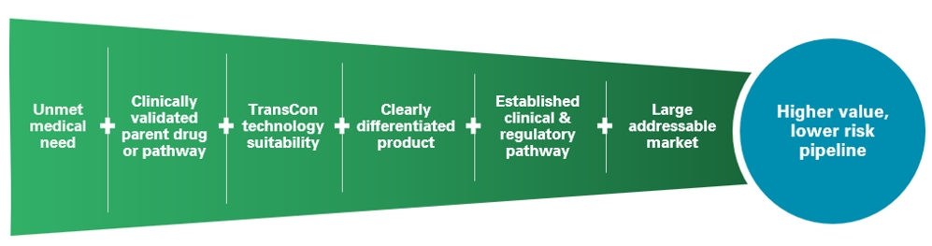
Ascendis Approach to Patient Centric Drug Design
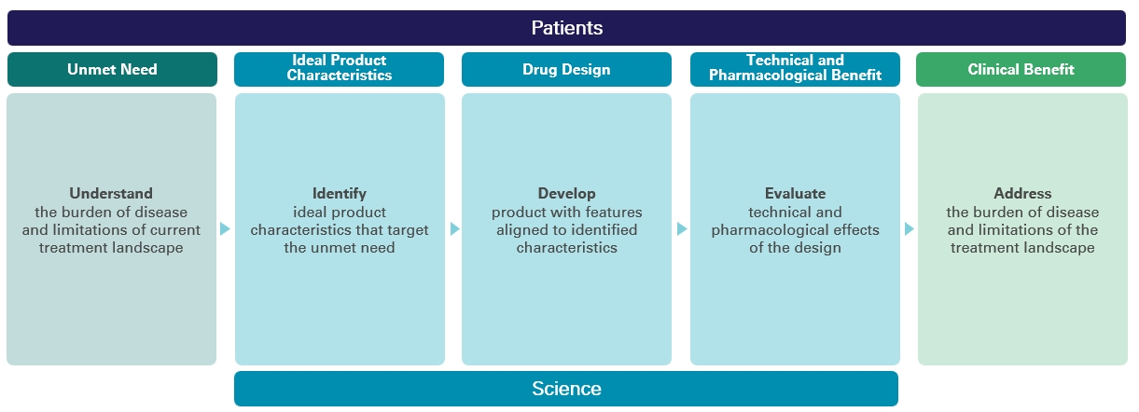
When we apply our TransCon technologies to clinically validated parent drugs or pathways, we may benefit from established clinical safety and efficacy data, which we believe increases the probability of success compared to traditional drug development. As illustrated above, our algorithm for product innovation focuses on identifying indications that have an unmet medical need, have a
3

clinically validated parent drug or pathway, are suitable to our TransCon technologies, have potential for creating a clearly differentiated product, have a potential established development pathway, and have the potential to address a large market. When the indication is identified we make use of patient centric drug design to optimally apply our TransCon technologies to address the unmet medical need.
Program Summaries
We currently have a diversified portfolio of three marketed products and three product candidates in clinical development in the area of Endocrinology Rare Disease. One of the three product candidates, TransCon CNP (navepegritide), is currently under review in the European Union (“EU”) for the treatment of children with achondroplasia. Additionally, we are working to apply our TransCon technology platform in additional therapeutic areas such as metabolic diseases, where we believe we have designed a potentially best-in-class, once-monthly glucagon-like peptide 1 (“GLP-1”) product.
•
YORVIPATH® (palopegteriparatide), was developed as TransCon PTH and was approved by the U.S. Food & Drug Administration (“FDA”), and authorized by the European Commission (“EC”) and other regulatory agencies for the treatment of adults with hypoparathyroidism. In the EU YORVIPATH is commercially available for prescription in our Europe Direct and International Markets, and is also available in other countries through named patient programs. In the United States, YORVIPATH has been commercially available for prescription since December 2024. In Japan, YORVIPATH has been commercially available for prescription since November 2025, through our partner Teijin Limited (“Teijin”). YORVIPATH has also been authorized by other regulatory authorities globally.
•
SKYTROFA® (lonapegsomatropin-tcgd) was developed as TransCon hGH and approved by the FDA for the treatment of pediatric patients one year and older who weigh at least 11.5 kg and have growth failure due to inadequate secretion of endogenous growth hormone, also known as growth hormone deficiency (“GHD”) and for the replacement of endogenous growth hormone in adults with GHD. SKYTROFA has been commercially available for prescription in the United States since October 2021. In addition, the EC has authorized SKYTROFA (lonapegsomatropin) in the EU for the treatment of children and adolescents (3 – 18 years) with growth failure due to GHD. In the EU, SKYTROFA has been commercially available for prescription in Germany since September 2023. SKYTROFA has also been authorized by other regulatory authorities globally including in China through our strategic collaboration partner, VISEN Pharmaceuticals (“VISEN”) in January 2026.
•
YUVIWEL® (navepegritide) was developed as TransCon CNP and approved by the FDA as a once-weekly treatment indicated to increase linear growth in children 2 years of age and older with achondroplasia with open growth plates (epiphyses). In the United States, YUVIWEL has been commercially available for prescription since April 2026. We also plan to make YUVIWEL available in certain International Markets through named patient programs. In the EU, a Marketing Authorisation Application (“MAA”) is under review with a decision expected in the fourth quarter of 2026.
•
Endocrinology Rare Disease Pipeline – Three product candidates in our Endocrinology Rare Disease portfolio are currently in development for additional indications and geographies. These product candidates are TransCon hGH (lonapegsomatropin) for children with Turner syndrome, TransCon PTH (palopegteriparatide) for adolescents with hypoparathyroidism, and TransCon CNP (navepegritide) for infants, children, and adolescents with achondroplasia. We are also investigating the combination of TransCon CNP and TransCon hGH in children with achondroplasia and other indications. In addition, we are investigating TransCon hGH in other established daily growth hormone indications and TransCon CNP, alone and in combination with TransCon hGH, for the treatment of children with hypochondroplasia, a related FGFR3-driven skeletal dysplasia. Through our strategic collaboration, Teijin is developing and, if approved, plans to commercialize TransCon hGH, and TransCon CNP for endocrinology rare diseases in Japan. In addition, VISEN is developing and, if approved, plans to commercialize TransCon PTH, and TransCon CNP for endocrinology rare diseases in the People’s Republic of China, Hong Kong, Macau, and Taiwan (“Greater China”).
TransCon Product Candidates Pipeline
Other than the rights we have granted to Eyconis, Inc. (“Eyconis”), Novo Nordisk A/S (“Novo Nordisk”), Teijin, and VISEN as noted in this report, we hold worldwide rights to our TransCon technologies and, other than our royalty financing arrangements with Royalty Pharma as noted in this report, we owe no third-party royalty or milestone payment obligations with respect to our TransCon technologies, TransCon hGH, TransCon PTH, TransCon CNP, or any of our other product candidates.
4

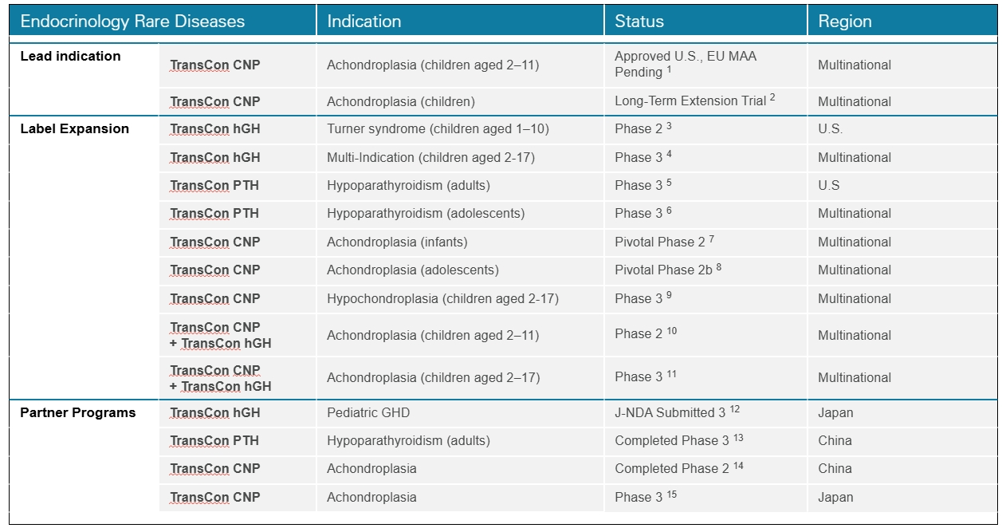
Note: The above chart lists our current clinical interventional trials related to the disclosed indication. Other ongoing clinical or observational studies not expected to directly support regulatory submissions are not disclosed.

1.
ApproaCH Trial (NCT05598320). Decision expected in the fourth quarter of 2026.
2.
AttaCH Trial (NCT05929807). Includes patients from ACcomplisH and ApproaCH.
3.
New InsiGHTS Trial (NCT05690386).
4.
HighLiGHts Trial (NCT07221851).
5.
PaTHway60 Trial (NCT07081997).
6.
PaTHway Adolescent Trial (NCT07706764).
7.
reACHin Trial (NCT06079398).
8.
teACH Trial (NCT06732895).
9.
HCH – Uplift Mono (NCT pending).
10.
COACH Trial (NCT06433557).
11.
CATCH Trial (NCT pending).
12.
Japanese riGHt Trial.
13.
PaTHway China Trial (NCT05387070).
14.
ACcomplisH China Trial (NCT05246033).
15.
Japanese ApproaCH Trial.
We maintain an intellectual property portfolio comprising over 465 granted patents and over 625 patent applications as of December 31, 2025, which includes patents and patent applications applicable to our products and product candidates with claims directed to composition of matter, process, formulation and/or methods-of-use for our products and product candidates, including a product-specific device and core TransCon technologies. While our TransCon prodrugs may incorporate already approved parent drugs or product candidates, TransCon hGH, TransCon PTH, TransCon CNP, and each of our other product candidates are new molecular entities and therefore eligible to be granted new intellectual property rights, including new composition of matter patents.
5

Global Commercialization Strategy
We are establishing a global presence to commercialize TransCon products, where approved, to address patients’ unmet medical needs.
In the U.S., we have established an integrated organization to commercialize our approved Endocrinology Rare Disease products, YORVIPATH, SKYTROFA and YUVIWEL. Our U.S. organization includes various departments, including sales, market access, patient support, and medical affairs teams. The sales team engages with healthcare providers to present products, usage, and safety guidelines in accordance with the label. Our market access team engages with health authorities, insurance companies, and payers to support patients in need of gaining access to our products. Our patient support team facilitates reimbursement support and out-of-pocket assistance and provides educational resources and product training. Our medical affairs team engages in scientific exchange with the physician and medical community. We have also established a network of specialty pharmacies to support product distribution.
In Europe, we have established our presence by building integrated organizations to commercialize our approved Endocrinology Rare Disease products in select countries, which we call “Europe Direct.”
Beyond the U.S. and Europe Direct, we are expanding global reach for our Endocrinology Rare Disease products through exclusive sales and distribution agreements with geographic market leaders, which we call “International Markets.” As of June 30, 2026, we have agreements covering over 75 countries.
Finally, we are making our Endocrinology Rare Disease products commercially available in China and Japan under exclusive license agreements with partners with local development and commercialization expertise and infrastructure, which we call strategic collaborations. In Japan, Teijin has exclusive license rights to develop and commercialize TransCon hGH, TransCon PTH, and TransCon CNP. In Greater China, VISEN has exclusive license rights to develop and commercialize TransCon hGH, TransCon PTH, and TransCon CNP.
Demand for our products has not been subject to material seasonal changes.
On April 2, 2025, an executive order was issued in the United States imposing “reciprocal tariffs” under the International Emergency Economic Powers Act (“IEEPA”), including a 10% baseline tariff and higher country-specific rates for certain trading partners, although specified pharmaceutical products were excluded. On February 20, 2026, the U.S. Supreme Court held that IEEPA does not authorize the U.S. president to impose tariffs, invalidating the IEEPA tariffs. The U.S. administration then imposed a temporary 10% import surcharge under Section 122 of the Trade Act of 1974, which excluded pharmaceuticals and pharmaceutical ingredients and expired by its terms on July 24, 2026. On April 2, 2026, the U.S. President issued a proclamation imposing Section 232 tariffs on covered patented pharmaceuticals and associated pharmaceutical ingredients. The tariff treatment became effective for companies identified in Annex III to the proclamation on July 31, 2026 and is scheduled to become effective for other companies on September 29, 2026, subject to applicable country-, product- and company-specific rates and exemptions. As the application, potential modification and duration of current and future tariff measures remain uncertain, we continue to monitor and assess the potential impact of existing and potential tariffs on our operations.
TransCon Technologies
Overview
Our TransCon technologies are designed to combine the benefits of conventional prodrug and sustained release technologies to solve the fundamental limitations seen in other approaches to extending duration of a drug’s action in the body, with the goal of developing highly differentiated product candidates based on efficacy, safety, tolerability, and convenience. In addition to retaining the original mode of action of the parent drug and potentially supporting dosing frequency from daily up to six months or more, we believe that predictable release over time can improve treatment safety and efficacy, increase the likelihood of clinical development success, and provide intellectual property benefits.
TransCon prodrugs can have up to three components: a parent drug, an inert TransCon carrier that protects it, and a TransCon linker that temporarily binds the two. When bound in prodrug form, the carrier inactivates the parent drug and shields it from receptor uptake, renal clearance, and enzymatic degradation. When injected into the body, physiologic pH and temperature conditions initiate sustained release of the active, unmodified parent drug at a predictable rate.
Depending upon the type of TransCon carrier we employ, we can design our TransCon prodrugs for sustained localized or systemic delivery.
6

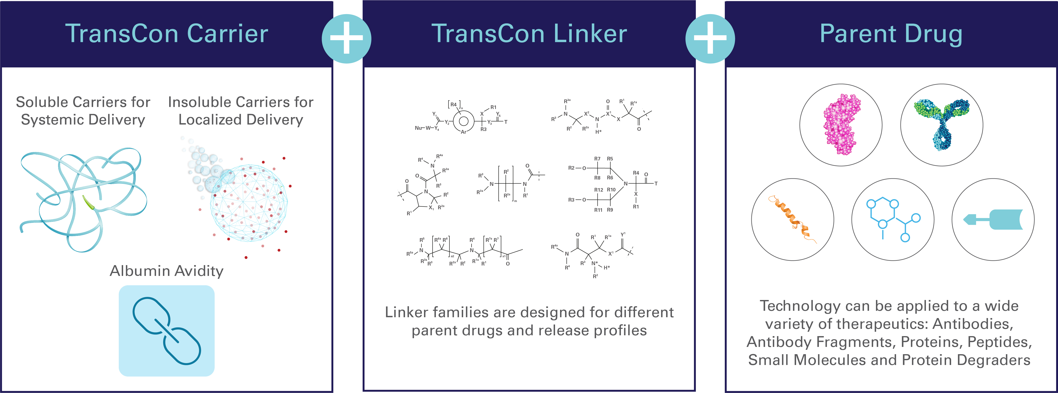
TransCon Technology Components
TransCon Carriers
Our TransCon technologies incorporate three carrier platforms that can be used to provide sustained localized or systemic drug exposure. These biocompatible carrier platforms include our TransCon systemic carriers and TransCon localized carriers (self-eliminating hydrogels). Our carriers inactivate and protect the drug through a shielding effect, which may prevent rapid excretion and degradation of the parent drug and enable benefits that include improved injection site tolerability, reduced systemic adverse effects, and low immunogenicity.
•
Systemic – Our TransCon systemic carriers are used to provide systemic drug exposure and are based on soluble compounds such as methoxypolyethylene glycol (“mPEG”) or other natural or synthetic polymers, as well as our albumin avidity approach, where 2 or more albumin binding moieties are incorporated into the drug molecule to facilitate sustained exposure. Prodrugs created using our systemic carriers are readily absorbed into the bloodstream after administration, thus minimizing exposure of the subcutaneous tissue to active drug, which we believe may improve injection site tolerability. TransCon hGH, TransCon PTH, and TransCon CNP utilize mPEG as a carrier molecule. mPEG is widely used to improve the pharmacokinetic or pharmacodynamic properties of marketed therapeutics. Below is an illustration of our systemic carrier:
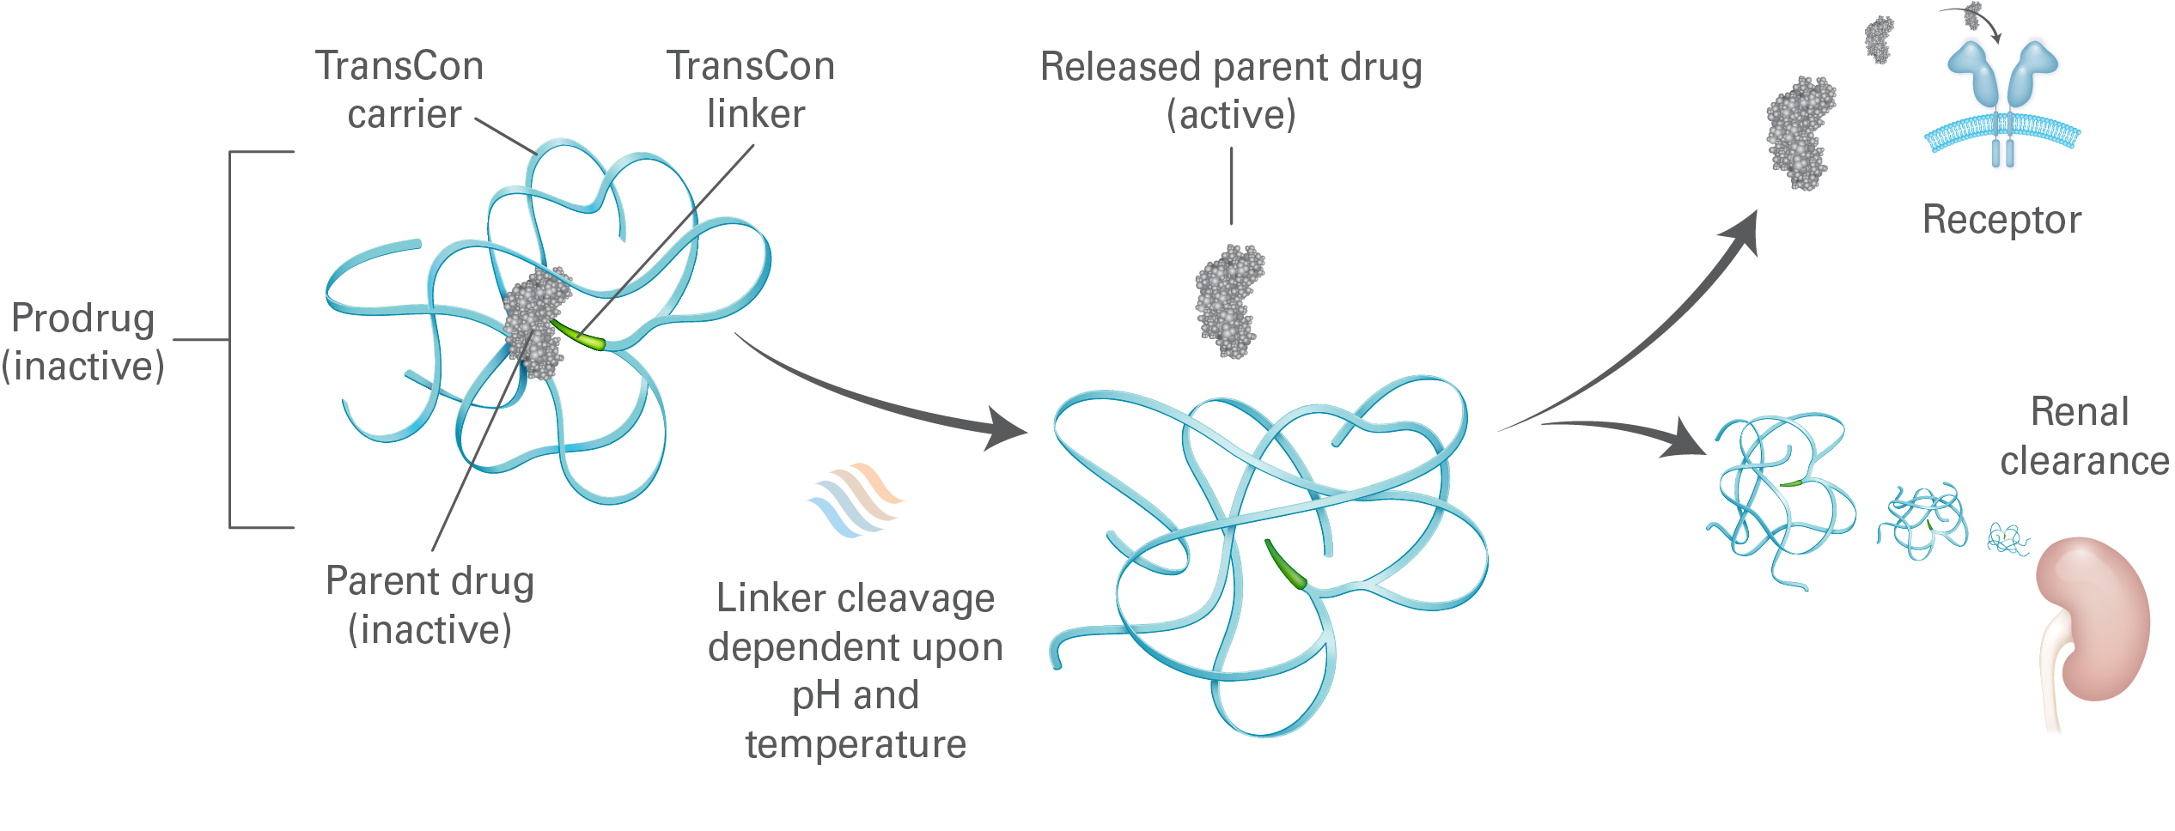
7

•
Localized – Our TransCon localized carriers include TransCon hydrogels based on PEG, hyaluronic acid, or other biopolymers. TransCon hydrogel is designed to self-eliminate to soluble, biocompatible molecules after the drug payload has been released. When applied for localized delivery, the TransCon hydrogel enables the release of a parent drug at high local concentrations within the target area while minimizing systemic exposure. We believe this may widen the therapeutic window for parent drugs that suffer from significant systemic side effects and toxicities, facilitating the development of highly efficacious product candidates with improved safety and tolerability profiles. Below is an illustration of our hydrogel carrier:
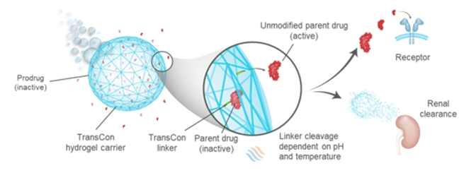
TransCon Linkers
Our reversible TransCon linkers are designed to enable the transient conjugation of a broad range of therapeutics, including proteins, peptides, and small molecules, to our TransCon carriers. We have a large library of TransCon linkers that may be applicable to various types of parent drugs, and that can be tailored to potentially achieve half-life extension enabling daily, weekly, monthly, and half-yearly dosing and to customize the potential pharmacokinetic profile for each individual product candidate with the goal of optimizing the potential therapeutic effect. TransCon linkers are self-cleaving through a process called intra-molecular assisted cleavage, which causes the linker to release the unmodified parent drug. We can tailor the release properties of the linker to a given therapeutic indication and parent drug by modifying the linker structures. We believe the self-cleaving process of our linker avoids many of the shortcomings of conventional prodrug technologies, which often depend on metabolic processes, such as enzymatic degradation, to convert the prodrug into the active drug. The rate of metabolic conversion of prodrugs in these types of processes may differ between patients, and even within different tissues in the same patient. As a result, conventional prodrugs do not always offer predictable release of the parent drug. Our TransCon linkers are designed to predictably release an unmodified active parent drug at predetermined rates governed by physiological pH and temperature conditions, which are tightly regulated in the body. Consequently, we believe we can design our prodrugs to release the unmodified parent drug at predictable rates.
Parent Drugs
Our TransCon technologies are applicable across a broad range of therapeutic classes and are currently used to create long-acting product candidates with best-in-class potential based on proteins, peptides, and small molecules. By primarily focusing on biological targets that have been clinically validated, we can leverage available knowledge regarding a target’s activity. Based on this selective approach, we know what drug levels must be maintained in the body for optimal efficacy and safety, and we can design the release half-life and dosing frequency of our TransCon prodrugs to maintain these levels to achieve the desired pharmacological effect. We move a product candidate into development after it demonstrates the desired profile in non-clinical models. Furthermore, based on the established translational relationships between preclinical animal models and clinical efficacy, we believe experimental results generated in animal models are highly predictive of clinical results and reduce the development risk for our TransCon prodrugs. This strategy is designed to reduce risk and increase productivity.
This approach has enabled us to develop three approved products and generate a pipeline of product candidates designed to address significant unmet medical needs. Because our TransCon technologies leverage clinically validated parent drugs or pathways, we believe we may benefit from a higher development and regulatory success rate compared to development of drug compounds without established biology.
TransCon Products and Product Candidates - Endocrinology Rare Disease
Hypoparathyroidism
Overview of Hypoparathyroidism
Hypoparathyroidism is a rare endocrine disease caused by insufficient levels of parathyroid hormone (“PTH”). As reported in a 2016 paper by Clarke BL, et al. (J Clin Endocrinol Metab. 2016 Jun;101(6):2284-99), most patients with hypoparathyroidism (70-80% of cases) develop the disease following damage to or accidental removal of the parathyroid glands during thyroid surgery. Other
8

etiologies include autoimmune disorders, genetic disorders such as autosomal dominant hypocalcemia type 1, and idiopathic causes. Conventional therapy with oral calcium and active vitamin D (also called calcitriol) does not effectively address the short-term symptoms, long-term complications, or quality-of-life impacts of hypoparathyroidism.
Individuals with hypoparathyroidism may experience a range of severe and potentially life-threatening short-term and long-term complications. Short-term symptoms of hypoparathyroidism include weakness; severe muscle cramps (tetany); abnormal sensations such as tingling, burning, and numbness (paresthesia); memory loss; impaired judgment; and headache. A survey published by Hadker et al. (Endocrine Pr. 20(7), 671–679), in 2014 of 374 individuals with hypoparathyroidism showed that 72% experienced more than ten symptoms in the preceding twelve months, with symptoms experienced for a mean of 13 ± 9 hours a day. Prolonged use of conventional therapy may increase the risk of major complications, such as calcium deposits in the brain, blood vessels, eyes, and soft tissues. According to a systematic review by Gosmanova et al. published in 2021, chronic hypoparathyroidism treated with conventional therapy is associated with higher rates of renal complications compared to the general population, including nephrolithiasis (up to 36%), nephrocalcinosis (up to 38%), and chronic kidney disease (up to 41%). Studies have found that the burden of hypoparathyroidism negatively impacts health-related quality of life (“QoL”), physical functioning, and psychological well-being. Compared with an age-matched general population sample, individuals with hypoparathyroidism have reported markedly lower health-related QoL, irrespective of serum calcium level, as measured by the physical (P<0.001) and mental (P<0.001) component scores of the 36-Item Short Form Health Survey (SF-36) as well as the EuroQol-5 Dimensions Visual Analogue Scale. As reported in a 2021 paper by Brod et al. (Qual of Life Res. 2021 Jan; 30(1):277-291), in interviews conducted on 42 individuals with hypoparathyroidism, 98% reported reduced functioning and well-being, including anxiety (81%), feeling sad or depressed (62%), and feeling irritable or short-tempered (43%) despite management with conventional therapy.
Hypoparathyroidism also imposes a substantial burden on the healthcare system despite the use of conventional therapy. For example, individuals with hypoparathyroidism may require hospitalizations or emergency department visits due to acute severe hypocalcemia (calcium crashes) and those with post-surgical hypoparathyroidism have an increased risk of hospitalization due to infection than age- and sex-matched controls from the general population. Individuals with hypoparathyroidism also have an increased risk of hospitalization due to renal complications, such as chronic kidney disease and renal failure, compared to age- and sex-matched controls. A 2019 retrospective review of clinical burden and healthcare resource utilization found that 90.7% of individuals had ≥1 hypoparathyroidism-related healthcare utilization event during a 12-month period, including 87.8% with ≥1 outpatient visit, 41% with ≥1 emergency department visit, and 19.5% with ≥1 hospitalization (Chen K, et al. J Med Econ. Nov 2019;22(11):1141-1152). The management of hypoparathyroidism is also associated with substantial economic burdens and consequences of hypoparathyroidism may negatively impact employment status and work productivity.
The 2022 Guidelines from the Second International Workshop addressing the prevention, diagnosis, and management of hypoparathyroidism were published in September 2022 in the Journal of Bone and Mineral Research and authored by leading clinicians from North America, Europe, and Asia. The authors suggest consideration of PTH replacement therapy in patients whose hypoparathyroidism is inadequately controlled with conventional therapy. Inadequate control is considered to be any one of the following: symptomatic hypocalcemia, hyperphosphatemia, renal insufficiency, hypercalciuria, or poor quality of life. In addition, the guideline indicates that individuals with poor compliance, malabsorption, or intolerant of large doses of calcium and active vitamin D may also benefit from PTH replacement therapy. Based on this current guideline, we believe PTH replacement therapy could be applicable to most patients with hypoparathyroidism.
Other companies and groups are developing therapies for hypoparathyroidism at the clinical stage, including Calcilytix (a BridgeBio company), Entera Bio/Opko Health, Extend Biosciences, AstraZeneca, MBX Biosciences, and Septerna.
Forteo® (teriparatide, PTH [1-34]), approved since 2002 for the treatment of osteoporosis, has sometimes been used for treatment of hypoparathyroidism using multiple daily injections, despite not being approved for this indication. Clinical research conducted by the U.S. National Institutes of Health in subjects receiving continuous exposure to PTH (1-34), administered by an infusion pump, demonstrated simultaneous normalization of serum calcium and urinary calcium, as well as normalization of bone turnover.
We estimate hypoparathyroidism affects more than 250,000 patients in the U.S. and Europe. In the U.S., we estimate hypoparathyroidism affects approximately 70,000 to 90,000 patients, including 4,000 to 5,000 patients who we estimate have previously been treated with PTH therapy. In Germany, we estimate hypoparathyroidism affects approximately 70,000 patients. Outside of Germany, we estimate hypoparathyroidism affects more than 100,000 patients in the rest of Europe.
TransCon PTH
TransCon PTH (palopegteriparatide) is a prodrug of PTH (1-34) that is administered once-daily to achieve and maintain a steady concentration of PTH in the bloodstream within the physiological range. TransCon PTH is designed to provide PTH in the physiological range for 24 hours per day, thereby more fully addressing aspects of the disease, including maintaining normal serum calcium and phosphate levels and normalizing urinary calcium.
9

TransCon PTH for the Treatment of Hypoparathyroidism
YORVIPATH (palopegteriparatide; developed as TransCon PTH) has received regulatory approval for the treatment of adults with hypoparathyroidism in the U.S., EU, Japan and several other countries. YORVIPATH is commercially available in the U.S., across major European markets, in Japan through our partner, Teijin, and other countries.
Clinical Development of TransCon PTH for Treatment of Hypoparathyroidism in Adults and Adolescents
TransCon PTH was evaluated for the treatment of hypoparathyroidism in adults in the completed Phase 2 PaTH Forward Trial and Phase 3 PaTHway Trial and is being evaluated in the ongoing Phase 3 PaTHway Japan Trial, the Phase 3 PaTHway60 Trial, and the PaTHway Adolescent Trial.
In June 2026, we announced new data from Week 182 (3.5 year) of our completed Phase 3 PaTHway Trial, confirming that long-term treatment with TransCon PTH (palopegteriparatide) continued to provide a durable response in adults with hypoparathyroidism regardless of its cause (post-surgical, autoimmune, genetic, or idiopathic), including improvements in biochemistries, kidney function, and quality of life. At Week 182, 86% of patients achieved the multi-component endpoint ((1) serum calcium in the normal range, (2) taking no active vitamin D, and (3) taking ≤600 mg/day of calcium). Reflecting clinically meaningful improvements in kidney function, improvements in eGFR from baseline were sustained through Week 182: mean (SE) eGFR increase of 11.0 (1.4) mL/min/1.73 m2 from baseline. Among patients randomized to TransCon PTH, eGFR increased from baseline through Week 38 and stabilized thereafter. After initiation of open-label treatment at Week 26, patients who had been receiving placebo in the double-blind period experienced a similar increase in eGFR. Following these eGFR increases, mean eGFR values were maintained through Week 182, in contrast to the expected typical age-related decline in eGFR in adults. As measured by Hypoparathyroidism Patient Experience Scales (HPES) and SF-36, patients treated with TransCon PTH reported rapid and sustained improvements in hypoparathyroidism-related symptoms, health-related quality of life, physical functioning and daily life through Week 182 of TransCon PTH treatment. In the trial, TransCon PTH treatment was generally well-tolerated, with no new safety signals identified. Treatment-emergent adverse events (AEs) were mostly mild or moderate, and no discontinuations were related to study drug. Over three and a half years of treatment, no patients developed anti-PTH antibodies. Seventy-three of the original 82 patients enrolled (89%) completed the three-and-a-half-year trial.
In June 2026, we announced new data from Week 266 (5 year) of our completed Phase 2 PaTH Forward Trial, confirming that long-term treatment with TransCon PTH (palopegteriparatide) continued to provide a durable response in adults with hypoparathyroidism regardless of its cause (post-surgical, autoimmune, genetic, or idiopathic), including improvements in biochemistries, kidney function, and quality of life. At Week 266, 82% of patients achieved the multi-component endpoint ((1) serum calcium in the normal range, (2) taking no active vitamin D, and (3) taking ≤600 mg/day of calcium). Reflecting clinically meaningful improvements in kidney function, improvements in eGFR from baseline were sustained through Week 266: mean (SE) eGFR increase of 9.4 (1.9) mL/min/1.73 m2 from baseline. Improvements were evident as early as Week 4, increased from baseline through Week 58 and were sustained over five years of treatment, in contrast to the expected typical age-related decline in eGFR in adults. As measured by Hypoparathyroidism Patient Experience Scales (HPES) and SF-36, patients treated with TransCon PTH reported rapid and sustained improvements in hypoparathyroidism-related symptoms, health-related quality of life, physical functioning and daily life through Week 266 of TransCon PTH treatment. In the trial, TransCon PTH treatment was generally well-tolerated, with no new safety signals identified. Treatment-emergent adverse events (AEs) were mostly mild or moderate, and no discontinuations were related to study drug. Over five years of treatment, one patient developed transient, low-titer and non-neutralizing anti-PTH antibodies, with no impact on safety or efficacy. Over five years of treatment, no other patients developed anti-PTH antibodies. Fifty-six of the original 59 patients enrolled (95%) completed the five-year trial.
On January 8, 2023, we announced top-line data from PaTHway Japan, a single-arm Phase 3 trial to evaluate the safety, tolerability, and efficacy of TransCon PTH in adults with hypoparathyroidism. The study achieved its primary objective, with top-line results consistent with our trials in North America and the EU. Twelve out of thirteen patients met the primary multi-component endpoint, which was defined as serum calcium levels in the normal range (8.3–10.6 mg/dL) and independence from conventional therapy (no active vitamin D and ≤600 mg/day of calcium). In this trial, TransCon PTH was generally well-tolerated, with no discontinuations related to study drug. The open-label extension (“OLE”) of this trial has been extended, and all patients have transitioned into the Investigational Medical Product supply period designed to ensure continuous treatment through the launch of YORVIPATH in Japan. In November 2025, Teijin announced that YORVIPATH is commercially available for prescription.
10

In March 2022, we announced that top-line data from the randomized, double-blind, placebo-controlled portion of the Phase 3 PaTHway Trial of TransCon PTH in adults with hypoparathyroidism demonstrated statistically significant higher proportion of participants treated with TransCon PTH achieved the primary multi-component endpoint compared to placebo. The primary endpoint, defined as serum calcium levels in the normal range (8.3–10.6 mg/dL) and independence from conventional therapy (no active vitamin D and ≤600 mg/day of calcium) with no increase in prescribed study drug within the 4 weeks prior to the Week 26 visit, was achieved by 78.7% of TransCon PTH-treated patients (48 of 61), compared to 4.8% for patients (1 of 21) in control group (p-value <0.0001). In addition, all key pre-specified secondary endpoints were met with statistical significance. TransCon PTH was generally well tolerated, with no discontinuations related to study drug. Three patients discontinued during the treatment period, two from the placebo arm and one from the TransCon PTH arm. TransCon PTH-treated patients showed a mean decrease in 24-hour urine calcium excretion into the normal range.
Growth Disorders
Market Opportunity for Recombinant Human Growth Hormone
GHD is a serious rare disease that affects both children and adults. Children with GHD are characterized by short stature, metabolic and cardiovascular abnormalities, cognitive deficiencies, and poor quality of life. GHD in adults is associated with increased adiposity, or fat mass, as well as psychiatric-cognitive, cardiovascular, muscular, metabolic and skeletal abnormalities. In childhood and adolescence, growth hormone plays an essential role in normal longitudinal growth, muscle and bone strength, and distribution of body fat. In adults, growth hormone contributes to body composition, cardiovascular function, and bone health. The current standard of care for GHD has been daily subcutaneous injections of somatropin, a recombinant human growth hormone (“hGH”). These daily hGH therapies have been shown to be safe and well-tolerated.
Since the introduction of hGH in 1981, a number of the world’s largest pharmaceutical companies have developed and marketed daily-administered hGH products. All currently marketed daily hGH products in the United States – Norditropin® (Novo Nordisk A/S), Humatrope® (Eli Lilly and Company), Genotropin® (Pfizer Inc.), Zomacton® (Ferring Pharmaceuticals, Inc.) and Omnitrope® (Sandoz GmbH) – contain unmodified somatropin and are administered by subcutaneous injections. The global market for daily hGH products is largely composed of products from Novo Nordisk, Pfizer, Eli Lilly, Sandoz, and Merck KGaA, which together account for most of the global market share. Eli Lilly has decided to permanently discontinue Humatrope® effective December 31, 2026, which might impact the hGH global market share in the future.
Primary indications for hGH in children are GHD, idiopathic short stature, chronic kidney disease, Prader-Willi syndrome, small for gestational age, and Turner syndrome. In adults, primary indications for hGH include GHD and AIDS-induced weight loss. We estimate pediatric indications comprise up to 90% of the total hGH market, of which approximately half is for pediatric GHD.
Since the 1990s, the pharmaceutical industry has employed various approaches to develop long-acting growth hormone products to reduce the burden of daily injections on patients and increase patient compliance with the dosing regimen. These approaches generally fall into two categories: unmodified somatropin and permanent modification of growth hormone:
•
Unmodified somatropin: Two long-acting growth hormone products using encapsulation technologies previously received regulatory approval in the U.S. and Europe, but were subsequently discontinued due to commercial challenges. These include Nutropin Depot®, formerly marketed by Genentech, and Somatropin Biopartners, developed by LG Life Sciences and Biopartners GmbH. Nutropin Depot was approved by the FDA in 1999 and later withdrawn; Somatropin Biopartners (LB03002) was authorized by the EC in 2013, and later withdrawn. We believe that the lack of market acceptance was a result of the various safety and tolerability issues that tend to arise with encapsulation technologies.
•
Permanent modification of growth hormone: Modification technologies prolong activity in the body by creating analogs of growth hormone through permanent modification of the growth hormone molecule. This modification may alter the molecular size and interaction with the growth hormone receptor and/or change the natural association affinity to endogenous proteins, as well as the distribution in the body. These changes may alter and reduce the efficacy of these drugs compared to unmodified daily somatropin and may also negatively impact the drug’s safety.
In February 2026, Novo Nordisk also received regulatory approval in the U.S. for once-weekly somapacitan (SOGROYA®) in three new pediatric indications; patients aged 2.5 years and older with idiopathic short stature (ISS), growth failure associated with Noonan syndrome and short stature born Small for Gestational Age with no catch-up growth by 2 years of age.
Pfizer (in collaboration with OPKO Health Inc.) received regulatory approval of once-weekly somatrogon (NGENLA) in various countries and regions including the U.S., Japan, and EU for pediatric GHD.
11

Several long-acting GH products are available in Asia, including the permanently PEGylated once-weekly therapies Jintrolong® developed by GeneScience Pharmaceuticals Co., Ltd. (approved in China for pGHD, Turner syndrome, and ISS) and Pegpesen® developed by Xiamen Amoytop Biotech Co., Ltd. (approved in China for pGHD), as well as LB03002 (Somatropin Biopartners), a sustained-release long-acting GH marketed in South Korea.
Other experimental growth hormone therapies based on permanent modification are in different stages of clinical development by various companies, including Genexine Inc. & I-Mab, UnionGene, Anhui Anke Biotechnology, Alteogen, JCR Pharmaceuticals Co., Ltd., Kexing Biopharm, Qianhong Biopharma (Zonhon), SCOHIA Pharma and Evive Biotech (Yifan).
TransCon Growth Hormone (hGH)
TransCon hGH (lonapegsomatropin) is a prodrug composed of somatropin that is transiently bound to a TransCon carrier by a proprietary TransCon linker. TransCon hGH is administered once weekly and is designed to maintain the same mode of action as daily therapies by providing sustained release of active, unmodified somatropin, the same recombinant growth hormone molecule used in the daily hGH therapies that have historically been the standard of care.
TransCon Growth Hormone (hGH) for Pediatric and Adult GHD
SKYTROFA® (lonapegsomatropin; developed as TransCon hGH) is approved in the U.S., Europe, and other regions for pediatric growth hormone deficiency and is approved in the U.S. for adult growth hormone deficiency. SKYTROFA is commercially available in the U.S., major European markets, and other countries.
Clinical Trial of TransCon hGH in Japanese Pediatric GHD
In the ongoing Phase 3 riGHt Trial, we are evaluating TransCon hGH (N=15) compared to somatropin (N=16) as a treatment in Japanese children with GHD. The trial achieved its primary objective with Week 52 top-line results consistent with our pivotal heiGHt Trial and VISEN’s Phase 3 trial. In the riGHt Trial, TransCon hGH was generally well tolerated with a safety profile that was similar to that of somatropin. Trial subjects continue in the extension period.
Proprietary Auto-Injector
SKYTROFA includes the SKYTROFA Auto-Injector and cartridges. The auto-injector provides for room temperature storage, includes an empty-all design, and is expected to last for at least four years. The device enables a single, low-volume injection of less than 0.6 mL for the majority of patients with a thin, 31-gauge needle that is only 4 millimeters in length, which is comparable to needles used to administer daily hGH. We are also working on strategies that will enable the auto-injector to integrate with the digital healthcare system, including Bluetooth connectivity features to allow for easy tracking of dosing adherence over time.
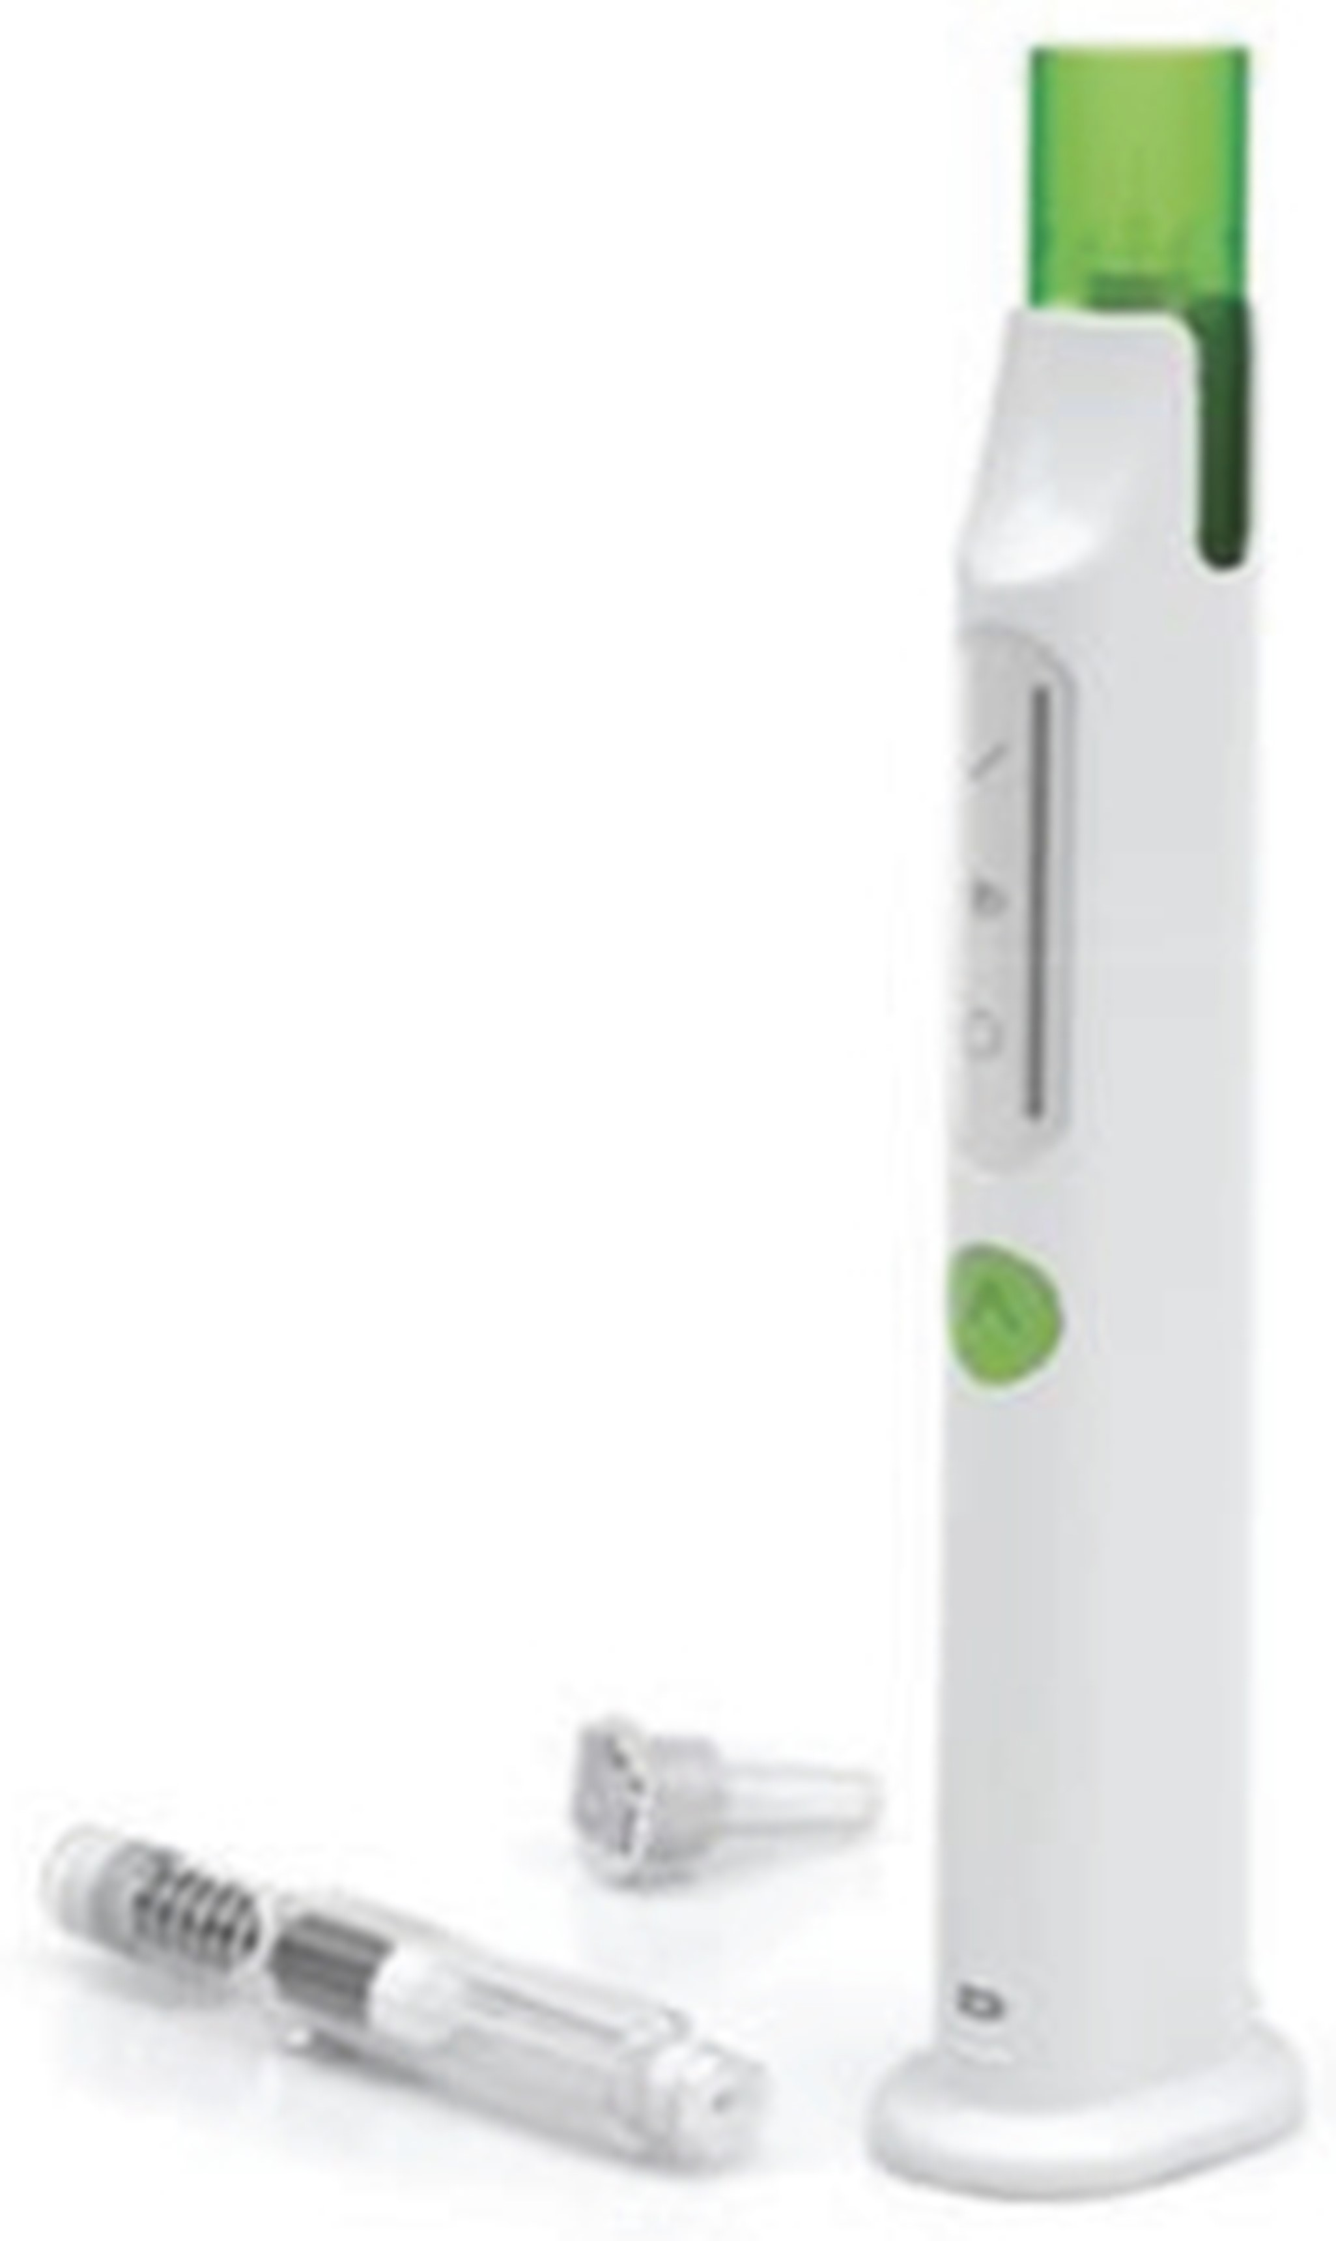
Figure: Our state-of-the-art auto-injector is designed to address important patient needs.
12

TransCon Growth Hormone (hGH) for Other Indications
In March 2026, we announced Week 52 top-line results from New InsiGHTS. At Week 52, children treated with TransCon hGH demonstrated an LS mean AHV of 9.05 cm/year, similar to 9.04 cm/year for children treated with daily somatropin, independent of starting dose. The mean dose at Week 52 was 0.22 mg/kg/week for TransCon hGH and 0.29 mg/kg/week for daily somatropin. TransCon hGH demonstrated a safety and tolerability profile similar to daily somatropin through follow-up of up to 143 weeks, with adverse events that were mild to moderate in severity and no adverse events leading to discontinuation of study drug. Additionally, there were no occurrences of slipped capital femoral epiphysis. TransCon hGH was generally safe and well tolerated, with five discontinuations from the trial for reasons unrelated to safety or efficacy of the study drug. As of June 30, 2026, 45 out of the 50 children are ongoing in the trial.
In December 2024, we announced positive top-line results from the Phase 2 New InsiGHTS Trial. New InsiGHTS randomized and dosed 49 children with Turner syndrome aged 1 to 10 years old into one of four treatment groups 1:1:1:1 – one of three starting doses of TransCon hGH (0.24, 0.30, or 0.36 mg/kg/week) or an active comparator of daily somatropin with a starting dose of 0.35 mg/kg/week. Doses were individualized based on IGF-1. On the primary endpoint of annualized height velocity (“AHV”) and secondary endpoint of change from baseline in height SDS, children treated with TransCon hGH demonstrated improved growth similar to daily somatropin at Week 26, independent of starting dose.
During the third quarter of 2025, we submitted the protocol for a basket trial evaluating additional growth disorder indications (planned for small for gestational age without catch-up growth; idiopathic short stature; SHOX deficiency (including Turner syndrome)). In addition, we are investigating potential combinations of TransCon hGH and TransCon CNP. For more information see the section entitled “Combination Therapy (TransCon CNP + TransCon hGH).”
Overview of Achondroplasia
Achondroplasia is a rare genetic condition arising from a systemic fibroblast growth factor receptor 3 (“FGFR3”) variant, which causes serious muscular, neurological, and cardiorespiratory complications in addition to the well-characterized skeletal dysplasia that leads to disproportionate short stature. Achondroplasia is associated with a well-delineated range of clinical complications and manifestations, occurring in about one in 10,000 to 30,000 newborns or more than 250,000 worldwide. Achondroplasia results in severe skeletal complications and comorbidities including spinal stenosis due to premature fusion of the foramen magnum, sleep apnea, chronic ear infections, and muscular complications. Patients often face multiple surgeries to alleviate its many complications. There is significant unmet need for treatments that ameliorate complications and improve quality of life in achondroplasia.
Achondroplasia is caused by gain-of-function variants of the FGFR3 gene resulting in constitutive activation of FGFR3 that leads to an imbalance between the effects of the FGFR3 and C-type natriuretic peptide (“CNP”) signaling. In achondroplasia, FGFR3 is constitutively activated, suppressing the differentiation of chondrocytes in the growth plate leading to poor endochondral bone growth and causing dysfunction in the skeletal muscle. Preclinical and clinical data show that therapeutic continuous CNP exposure helps to counteract the constitutively activated FGFR3 downstream.
In November 2021, BioMarin Pharmaceutical Inc.’s (“BioMarin”) daily VOXZOGO® (vosoritide) was approved by the FDA to increase linear growth in pediatric patients with achondroplasia with open epiphyses. Additionally, BioMarin is developing a long-acting CNP product candidate.
BioMarin has initiated certain legal proceedings aimed at delaying or preventing patient access to TransCon CNP. We believe BioMarin’s claims lack merit and that these actions threaten potential harm to patients by limiting or preventing access to a treatment option that has the potential to address multiple unmet clinical needs.
These legal proceedings include a case filed by BioMarin before the Unified Patent Court (“UPC”) in Munich related to alleged infringement against EP3175863 (the “‘863 patent”), along with a complaint filed with the U.S. International Trade Commission (“ITC”) related to alleged infringement of U.S. Reissue Patent No. 48,267. Trial in the ITC took place this April 2026. In response to the ITC action, we initiated legal action before the District Court in the U.S. Northern District of California. The District Court litigation has been stayed in view of the pending ITC proceedings.
13

In the European case, we took the view that we did not infringe the ‘863 patent and that the patent was, in any event, invalid. Following opposition proceedings against the ‘863 patent that were initiated before the European Patent Office (“EPO”) in September 2022, the EPO Technical Boards of Appeal revoked the ‘863 patent in its entirety on October 16, 2025. As a consequence of the revocation, the UPC dismissed the infringement case on December 29, 2025, which included an agreement for BioMarin to reimburse Ascendis for certain legal expenses related to the case. In addition, we have instituted proceedings before the Danish Maritime and Commercial High Court, claiming entitlement to European patent applications EP21211450.8, EP25151367.7 and EP25175852.0, all of which are divisional applications of the revoked ‘863 patent. The EPO has granted a stay of proceedings with respect to these divisional applications. BioMarin is challenging such stays at the German Courts in Munich. On August 7, 2026, the Legal Division of the EPO issued a formal decision rejecting BioMarin’s request for a resumption of proceedings with respect to EP21211450.8.
On June 12, 2025, BioMarin also submitted a Citizen Petition to the FDA under Section 505(q) of the Federal Food, Drug and Cosmetic Act requesting that FDA refrain from approving any analog of human CNP as a treatment for achondroplasia until orphan-drug exclusivities applicable to VOXZOGO expire. We submitted a response to the FDA in September 2025 and in February 2026, the FDA denied the Citizen Petition.
Also, on October 21, 2025, we filed a petition before the Korean Intellectual Property Trial and Appeal Board (“IPTAB”) for the invalidation of BioMarin’s Korean patent KR2033680.
Furthermore, on March 11, 2026, we filed two lawsuits in Brazil relating to BioMarin’s Brazilian patent, BR 12 2019 026832 0. One suit was filed in the Federal Court Rio de Janeiro, requesting revocation of the patent and the other suit filed at the State Court São Paulo, requesting the court for a declaratory judgement of non-infringement of our YUVIWEL product.
Changing the Treatment Paradigm of Achondroplasia
Clinical manifestations of achondroplasia are associated with significant, potentially life-threatening complications and reduced quality of life. While achondroplasia has historically been considered a growth disorder, secondary manifestations beyond linear growth, including reduced muscle strength and stamina, suggest that achondroplasia is also a muscle disorder.
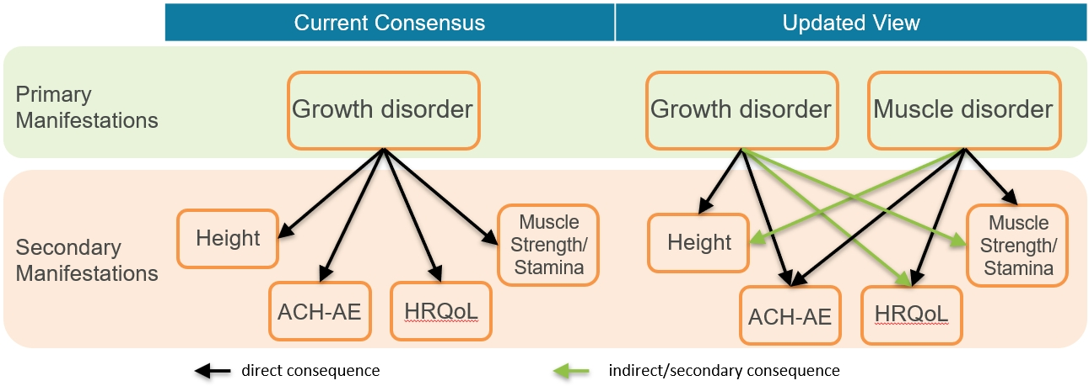
ACH-AE: Increased incidence of Achondroplasia-related Adverse Events.
HRQoL: Reduced Health-Related QOL; Height; Reduced height. Muscle Strength/Stamina; Reduced muscular functionality, including reduced strength and stamina.
TransCon CNP
TransCon CNP (navepegritide) is a prodrug of CNP administered once weekly and designed to provide sustained release of active CNP supporting continuous exposure for the treatment of achondroplasia. TransCon CNP is designed to provide effective shielding of CNP from neutral endopeptidase degradation in subcutaneous tissue and the blood compartment, minimize binding of CNP to the NPR-C receptor to decrease clearance, and release unmodified CNP (89-126), which is small enough in size to allow effective penetration into growth plates. Shorter-acting CNP and CNP analogs in development have resulted in high maximum serum concentration (“Cmax”) levels that may cause adverse hypotensive events. We believe the sustained release of active CNP offers advantages that may mitigate this issue, leading to continuous CNP exposure while avoiding a high Cmax to correlate with better therapeutic outcomes.
14

TransCon CNP for the Treatment of Achondroplasia
In February 2026, we received accelerated approval of YUVIWEL (navepegritide; developed as TransCon CNP) for the treatment of pediatric patients 2 years of age and older with achondroplasia with open epiphyses. Additionally in March 2026, the FDA granted Orphan Drug exclusivity to YUVIWEL, providing seven years of market exclusivity for YUVIWEL in the United States for the treatment of pediatric patients 2 years of age and older with achondroplasia with open epiphyses.
In addition, we submitted a Marketing Authorisation Application (“MAA”) to the European Medicines Agency (“EMA”) for the treatment of children with achondroplasia on October 8, 2025.
In February 2019, we were granted ODD by the FDA for TransCon CNP for the treatment of achondroplasia. In July 2020, we received ODD from the EC for TransCon CNP for the treatment of achondroplasia.
Clinical Development of TransCon CNP for Achondroplasia
Our pivotal ApproaCH Trial, our Phase 2 ACcomplisH Trial, and our long-term extension trial AttaCH, are evaluating the safety and efficacy of TransCon CNP in children with achondroplasia. The reACHin Trial is evaluating the safety, tolerability, and efficacy of TransCon CNP in infants with achondroplasia (aged 0 to < 2 years at the time of randomization). The teACH Trial is evaluating the safety, tolerability, and efficacy of TransCon CNP in adolescents with achondroplasia (aged 12 to <18).
In August 2026, we announced that 96% of the 140 children enrolled in the AttaCH long-term open-label extension trial remain on therapy, either receiving TransCon CNP monotherapy with treatment duration of up to nearly six years or participating in the ongoing COACH combination therapy trial.
In June 2026, we announced new radiographic data from Week 104 of the completed pivotal ApproaCH Trial showing that children with achondroplasia treated with once-weekly TransCon CNP (navepegritide) demonstrated continued improvements in lower extremity alignment through up to two years of treatment, including improvements in tibial-femoral angle (TFA). The data also showed that greater improvements were observed in children with preexisting genu varum (leg bowing). Additionally, improvements in annualized growth velocity were maintained and ACH-specific height Z-score increased with TransCon CNP treatment through Week 104. Through up to two years of treatment, TransCon CNP was generally well tolerated, with a low rate of ISRs (all mild), no symptomatic hypotension, and no acceleration of bone age. Most adverse events in TransCon CNP-treated children were mild or moderate, with none leading to treatment discontinuation or withdrawal from the trial.
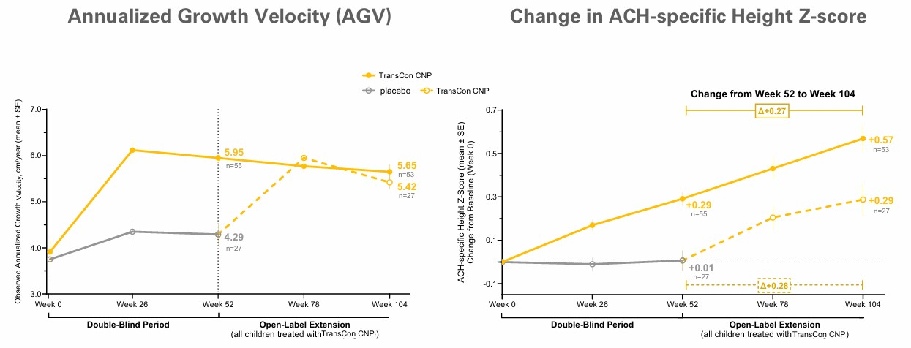
15

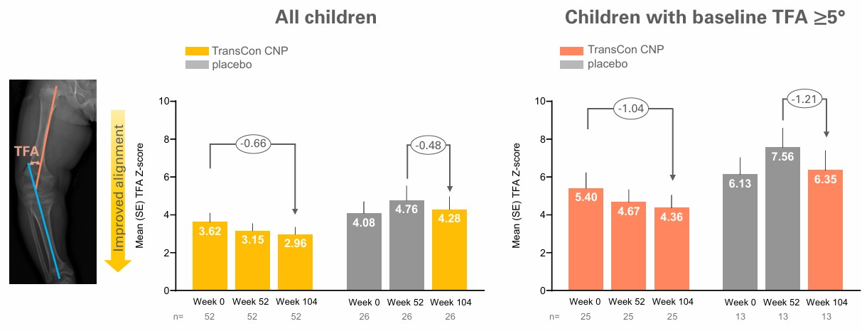
In May 2026, we announced expanded data building on findings presented at the 2026 Pediatric Endocrine Society Annual Meeting recently presented showing that children with achondroplasia ≥5 years of age at enrollment treated with once-weekly TransCon CNP (navepegritide) in its pivotal ApproaCH Trial demonstrated statistically significant improvements in growth compared to placebo after 52 weeks and sustained these improvements through two years of treatment. Through two years of treatment, TransCon CNP was generally well-tolerated across age groups, and safety profile in children ≥5 years was similar to the overall population. Most adverse events were mild or moderate, with none leading to treatment discontinuation or withdrawal. There were no occurrences of symptomatic hypotension, no acceleration of bone age, and the ISR rate was low (all mild) at 0.35 per person-year of exposure, approximately one ISR for every three years of treatment.
In March 2026, we announced new two-year data from the pivotal ApproaCH Trial, which were shared in an oral presentation during the Annual Clinical Genetics Meeting of the American College of Medical Genetics and Genomics ("ACMG"). The data showed that children with achondroplasia treated with once-weekly TransCon CNP maintained consistent improvements in growth through Week 104, with further improvement in body proportionality during the second year of treatment. TransCon CNP was generally well-tolerated, with most adverse events in TransCon CNP-treated children mild or moderate in severity and none leading to treatment discontinuation or withdrawal from the trial. There were no occurrences of symptomatic hypotension, and the overall rate of injection-site reactions, all of which were mild was 0.35 per person-year of exposure. Retention in the pivotal ApproaCH Trial was strong, with 80 of 84 children enrolled completing the trial, and all 80 children enrolled into the long-term, open-label AttaCH extension trial.
In November 2025, we announced that Week 52 results from the pivotal ApproaCH trial were published in JAMA Pediatrics titled “Once-Weekly Navepegritide in Children with Achondroplasia: The ApproaCH Randomized Clinical Trial.” The authors reported that treatment with TransCon CNP led to significantly higher annualized growth velocity (AGV) at Week 52 compared to placebo (primary endpoint), as well as improved lower limb alignment and body proportionality and positive changes in health-related QOL, with a safety and tolerability profile similar to placebo. The publication is available at Savarirayan R, et al. JAMA Pediatr. 2026;180(1):18-25. doi:10.1001/jamapediatrics.2025.4771.
In September 2025, we announced new analyses from the pivotal ApproaCH Trial were presented at the American Society for Bone and Mineral Research (ASBMR) Annual Meeting. The new analyses showed that children treated with TransCon CNP had improvements in the Physical Functioning domain of the Achondroplasia Child Experience Measure (ACEM-PF), with greatest benefits in younger children who had more severe genu varum (≥5°) at baseline, supporting benefits beyond linear growth. Further analyses showed correlations between improvements in physical functioning and improvements in lower limb alignment in these children, supporting the potential for TransCon CNP to provide benefits beyond linear growth.
In May 2025, we announced data demonstrating improvements in growth and bone morphometry from Week 52 of our pivotal ApproaCH Trial of TransCon CNP (navepegritide) in children with achondroplasia. TransCon CNP demonstrated superiority over placebo in annualized growth velocity (AGV), with a safety and tolerability profile comparable to placebo that included a low rate of injection site reactions, no treatment-related serious adverse events (SAEs), no cases of symptomatic hypotension, no fractures, and no acceleration of bone age versus chronological age. Analyses also showed that TransCon CNP improved aspects of bone morphometry at Week 52. This included improvement in lower limb alignment and proportional growth, as well as increases in spinal canal dimensions, versus placebo.
16

In January 2025, we announced data demonstrating improvements in leg bowing, a common complication in achondroplasia, observed with TransCon CNP compared to worsening observed with placebo in the pivotal ApproaCH Trial.
In September 2024, we announced top-line data from ApproaCH, a pivotal, multicenter, randomized, double-blind, placebo-controlled trial of once-weekly TransCon CNP versus placebo in 84 children (aged 2 to 11 years) with achondroplasia. Participants were randomized 2:1 to receive TransCon CNP 100 µg/kg/week or placebo for 52 weeks in the double-blind period, after which all participants could choose to receive TransCon CNP at 100 µg/kg/week dose in an ongoing open-label extension. In the trial, children treated with once-weekly TransCon CNP demonstrated annualized growth velocity (“AGV”) superior to those treated with placebo. TransCon CNP also demonstrated statistically significant improvements in other growth parameters, including height Z-score and change from baseline AGV.
Highlights of the ApproaCH Trial Top-line Data
Primary Endpoint
•
For the primary endpoint of AGV at Week 52, children treated with TransCon CNP (n=57) demonstrated an LS mean AGV of 5.89 cm/year compared to 4.41 cm/year in the placebo arm (n=27), an LS mean difference of 1.49 cm/year (p<0.0001).
•
Sub-group analyses:
o
Children aged 2 to <5 years treated with TransCon CNP (n=21) demonstrated an LS mean AGV at Week 52 of 6.07 cm/year compared to 5.06 cm/year in the placebo arm (n=10), an LS mean difference of 1.02 cm/year (p=0.0084).
o
Children aged 5-11 years treated with TransCon CNP (n=36) demonstrated an LS mean AGV at Week 52 of 5.79 cm/year compared to 4.02 cm/year in the placebo arm (n=17), an LS mean difference of 1.78 cm/year (p<0.0001).
AGV Change from Baseline
•
Children aged 2 to <5 years, treated with TransCon CNP (n=19) demonstrated a change from baseline AGV at Week 52 of 1.57 cm/year compared to 0.43 cm/year in the placebo arm (n=10), an LS mean difference of 1.15 cm/year (p=0.0047).
•
Children aged 5-11 years, treated with TransCon CNP (n=35) demonstrated a change from baseline AGV at Week 52 of 2.29 cm/year compared to 0.52 cm/year in the placebo arm (n=17), an LS mean difference of 1.78 cm/year (p<0.0001).
Secondary Endpoints
•
For the secondary endpoint of change in achondroplasia-specific height Z-score, children treated with TransCon CNP (n=57) demonstrated an LS mean change from baseline achondroplasia-specific height Z-score of 0.30 compared to 0.01 in the placebo arm (n=27), an LS mean difference of 0.28 (p<0.0001).
•
For the secondary endpoint of change in CDC-based height Z-score, children treated with TransCon CNP (n=55) demonstrated an LS mean change from baseline CDC Height Z-score of 0.15 compared to -0.15 in the placebo arm (n=27), an LS mean difference of 0.30 (p=0.0003).
Safety Results Summary
•
TransCon CNP was generally well-tolerated and demonstrated safety profile similar to that observed in the placebo arm, with generally mild treatment emergent adverse events (“TEAEs”), no evidence of hypotensive effect, and a low frequency of injection site reactions (0.41 events per patient year), all mild.
•
No adverse events (“AEs”) led to discontinuation of TransCon CNP or withdrawal from the trial and no serious adverse events (“SAEs”) were assessed as related to TransCon CNP.
In December 2023, we announced new analyses demonstrating benefits beyond linear growth from the blinded and ongoing OLE periods of ACcomplisH, a Phase 2 randomized, double-blind, placebo-controlled, dose-escalation trial of TransCon CNP in children aged 2 to 10 years with achondroplasia. In the trial, all 57 patients have now completed one year of treatment with TransCon CNP at 100 µg/kg/week, the dose agreed with regulatory agencies for the active arm in our pivotal ApproaCH Trial.
We analyzed available data for patients who only received TransCon CNP at the 100 µg/kg/week dose in either the blinded or OLE period and were treated for one year (n=19), compared to those administered placebo for one year (n=15). Results showed that these TransCon CNP-treated patients (data available for 9-16 patients) showed improvements (nominal p-value <0.05) in health-related QoL and disease impacts compared to those receiving placebo (data available for 5-13 patients).
17

Assessments were performed with the SF-10 (a 10-item non-condition specific survey of a child’s functional health and well-being that has been validated to assess children aged 5 years and older) and the Achondroplasia Child Experience Measure (“ACEM”) a condition-specific clinical outcome measure that assesses the impact of achondroplasia on a child’s health-related QOL, with statistically significant improved outcome in TransCon CNP-treatment versus placebo for:
•
SF-10 Physical Summary (p=0.002, aged 5 years and older)
•
ACEM Daily Living Function (p=0.047)
•
ACEM Emotional Well-being (p=0.045)
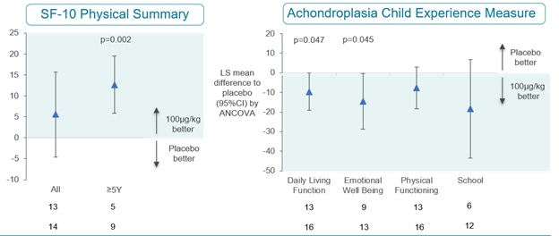
The 46 children switching from placebo or a lower dose of TransCon CNP to the 100 µg/kg/week dose in the OLE demonstrated improved growth after one year of treatment, similar to the growth benefits seen in the 11 children treated with 100 µg/kg/week in the one-year randomized, double-blind period of ACcomplisH.
During the third quarter of 2023, we filed an Investigational New Drug Application amendment with the FDA to initiate reACHin, a Phase 2, multicenter, double-blind, randomized, placebo-controlled trial, designed to evaluate the safety, tolerability, and efficacy of 100 μg/kg of TransCon CNP once-weekly for 52 weeks in infants with achondroplasia, aged 0 to < 2 years at the time of randomization.
In November 2022, we announced top-line results from ACcomplisH, a Phase 2 randomized, double-blind, placebo-controlled, dose-escalation trial evaluating the safety and efficacy of once-weekly TransCon CNP compared to placebo in children with achondroplasia aged 2 to 10 years old.
The ACcomplisH Trial evaluated 57 children with achondroplasia aged 2 to 10 years old, randomized in a 3:1 ratio to receive either sequential ascending doses of once-weekly TransCon CNP (6 µg/kg/week, 20 µg/kg/week, 50 µg/kg/week, 100 µg/kg/week) or placebo for 52 weeks. The trial met its primary objectives, demonstrating that TransCon CNP at 100 µg/kg/week (n=11) was superior to placebo (n=15) on the primary efficacy endpoint of AGV at 52 weeks (p=0.0218).
The ACcomplisH Trial completed in October 2024, with 53 of the original 57 children transitioning into AttaCH, a multicenter, long-term, open-label extension trial to continue treatment with TransCon CNP 100 µg/kg/week, and two into COACH, a TransCon CNP and TransCon hGH combination therapy trial. Two children did not roll-over for reasons unrelated to safety or efficacy of the study drug. For more information, see section entitled, “Combination Therapy TransCon CNP + TransCon hGH.”
As of June 30, 2026, of the 53 children that rolled over from ACcomplisH, 41 children continue in AttaCH with 5 children withdrawn from treatment, for reasons unrelated to safety or efficacy of the study drug. Seven children from AttaCH were enrolled and continue in COACH. For more information, see section entitled, “Combination Therapy TransCon CNP + TransCon hGH.”
In 2019, we initiated the ACHieve Study, a five-year, multi-center natural history study designed to gain insight into the experiences of pediatric patients with achondroplasia. ACHieve was designed to evaluate growth velocity, body proportionality, and comorbidities over time in children with achondroplasia up to eight years old. No study medication was administered in the ACHieve Study. The study ended in the first quarter of 2024.
18

Combination Therapy (TransCon CNP + TransCon hGH)
TransCon CNP has demonstrated improvement in linear growth and in benefits beyond height. Clinical use of daily growth hormone monotherapy has demonstrated some growth improvements in children with achondroplasia; however, without reports of benefits beyond height, as it does not address the underlying overactive FGFR3 signaling pathway.
We believe the combination of once-weekly TransCon CNP and TransCon hGH, through two independent and complementary mechanisms of action, may provide benefits beyond monotherapies in achondroplasia. The active CNP released from TransCon CNP continuously relieves the pre-hypertrophic block in the growth plate, enabling the strong complementary effect of unmodified somatropin released from TransCon hGH.
COACH, a Phase 2 open-label single-arm trial is the first clinical trial to evaluate combination treatment with once-weekly investigational TransCon CNP (navepegritide) and once-weekly TransCon hGH (lonapegsomatropin) in children with achondroplasia (age 2 to 11 years). The primary objective is to evaluate the treatment effect on linear growth and safety. Secondary objectives are to evaluate treatment effect on quality of life, radiological endpoints, physical functioning, and body composition. The trial enrolled 21 children (treatment naïve, n=12; prior treatment with TransCon CNP (100 µg/kg/week) for at least 1 year, n=9).
In August 2026, we announced new data from Week 78 of the ongoing Phase 2 COACH Trial continuing to demonstrate sustained growth in children with achondroplasia, with a mean annualized growth velocity (“AGV”) meeting or exceeding the 97th percentile of children of average stature, without compromising safety or tolerability at Week 78. Safety and tolerability were consistent with those observed for TransCon CNP and TransCon hGH monotherapies. Combination therapy was generally well-tolerated, with a low incidence of injection site reactions and generally mild treatment-emergent adverse events.
TransCon CNP monotherapy improved growth rates in line with children of average stature, while combination therapy enhanced growth even further.
For the TransCon CNP treatment-naïve cohort, mean AGV at Week 78 was 7.73 cm/year, with an increase in mean ACH height Z-score of +1.29, increasing from 0.46 to 1.75 over 78 weeks.
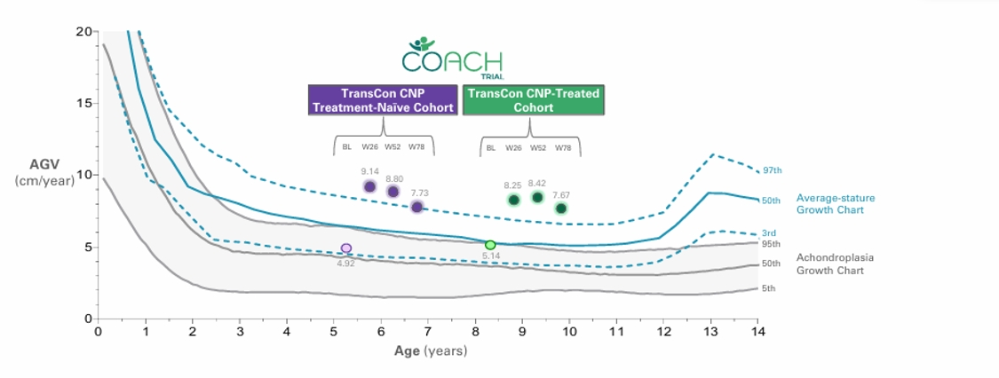
Hoover-Fong JE, et al. Am J Clin Nutr. 2008 Aug;88(2):364-71. Natural history AGV curves presented for male children; curves for average stature children from 0-3y reflect 10th, 50th, and 90th percentile.
19

For the TransCon CNP-experienced cohort (mean treatment duration with TransCon CNP of 2.56 years), mean AGV at Week 78 was 7.67 cm/year, with an improvement in mean ACH height Z-score of +1.10, increasing from 1.28 to 2.38 over 78 weeks.
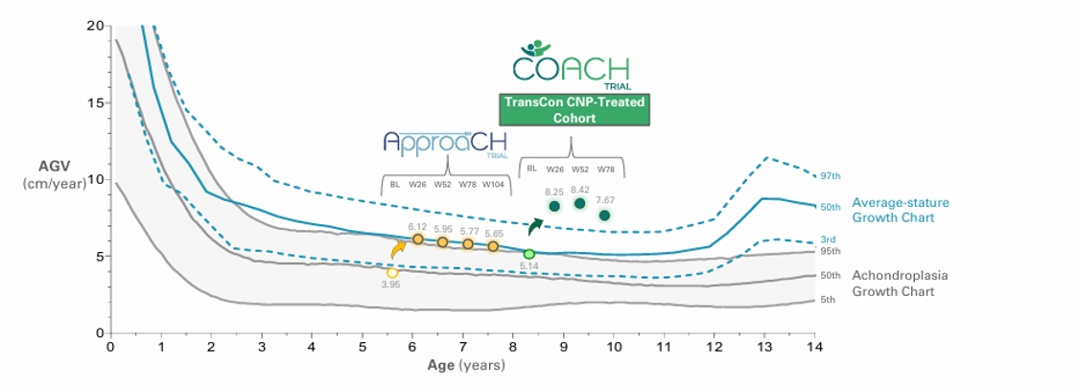
Hoover-Fong JE, et al. Am J Clin Nutr. 2008 Aug;88(2):364-71. Natural history AGV curves presented for male children; curves for average stature children from 0-3y reflect 10th, 50th, and 90th percentile.
Sustained increases in ACH height Z-scores through Week-78, indicate a tripling of efficacy compared to TransCon CNP monotherapy
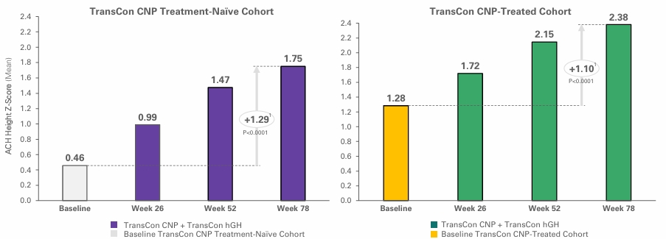
Through Week 78, children treated with combination therapy demonstrated continued improvements in body proportionality aligning with the increase in linear growth.
20

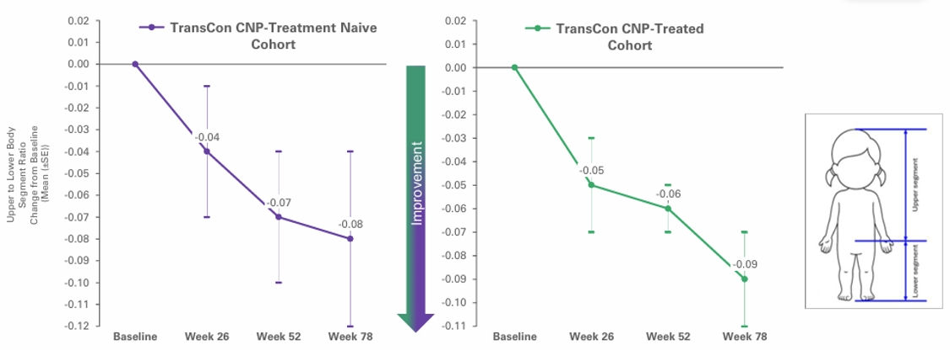
As of August 6, 2026, the COACH Trial maintained 100% retention through Week 78, with all 21 enrolled children remaining on therapy.
In April 2026, we announced data from Week 52 of the ongoing Phase 2 COACH Trial demonstrating that combination therapy with once-weekly TransCon CNP and once-weekly TransCon hGH accelerated benefits beyond linear growth in children with achondroplasia, with unprecedented improvements observed in arm span, and enhanced improvements in spinal canal dimensions, and leg bowing.
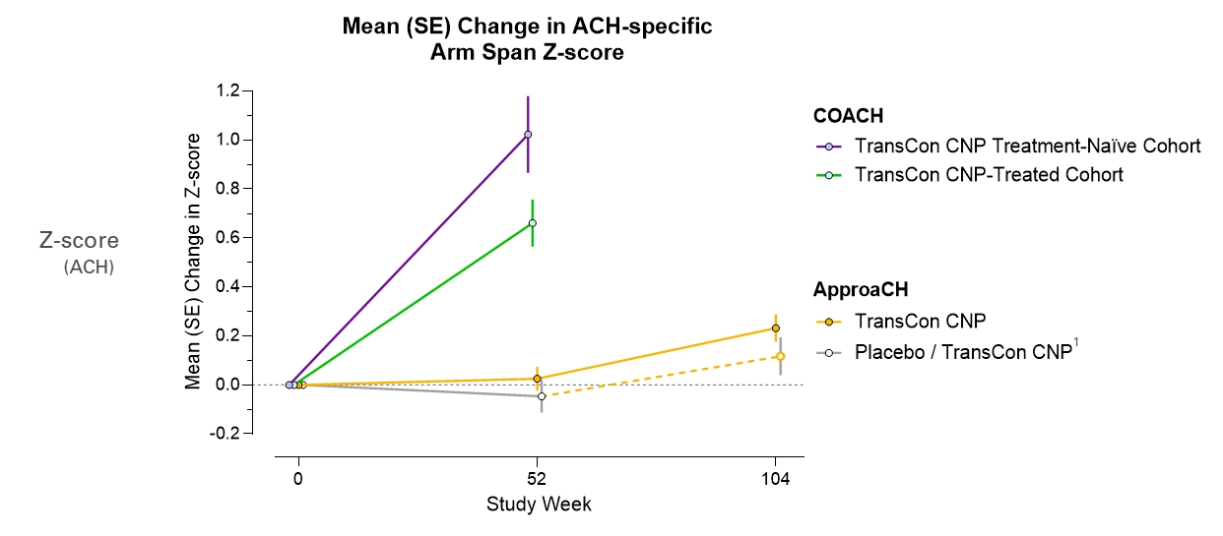
1ApproaCH placebo patients crossed over to TransCon CNP therapy at Week 52.
Unprecedented improvements in arm span observed at Week 52 with TransCon CNP and TransCon hGH combination therapy, a measure highly meaningful to the achondroplasia community, with the mean change from baseline in achondroplasia (ACH)-specific arm span Z-scores at Week 52 for TransCon CNP treatment-naïve and TransCon CNP-treated children in COACH were +1.02 and +0.66, respectively. The TransCon CNP treatment-naïve cohort improved +9.4 cm and the TransCon CNP-treated cohort improved +7.9 cm. By comparison, humeral gain by limb lengthening surgery is approximately 8 cm per arm and carries a high complication risk (Hosny G, et al. International Orthopaedics. Published online March 16, 2026. doi: https://doi.org/10.1007/s00264-025-06720-z).
21

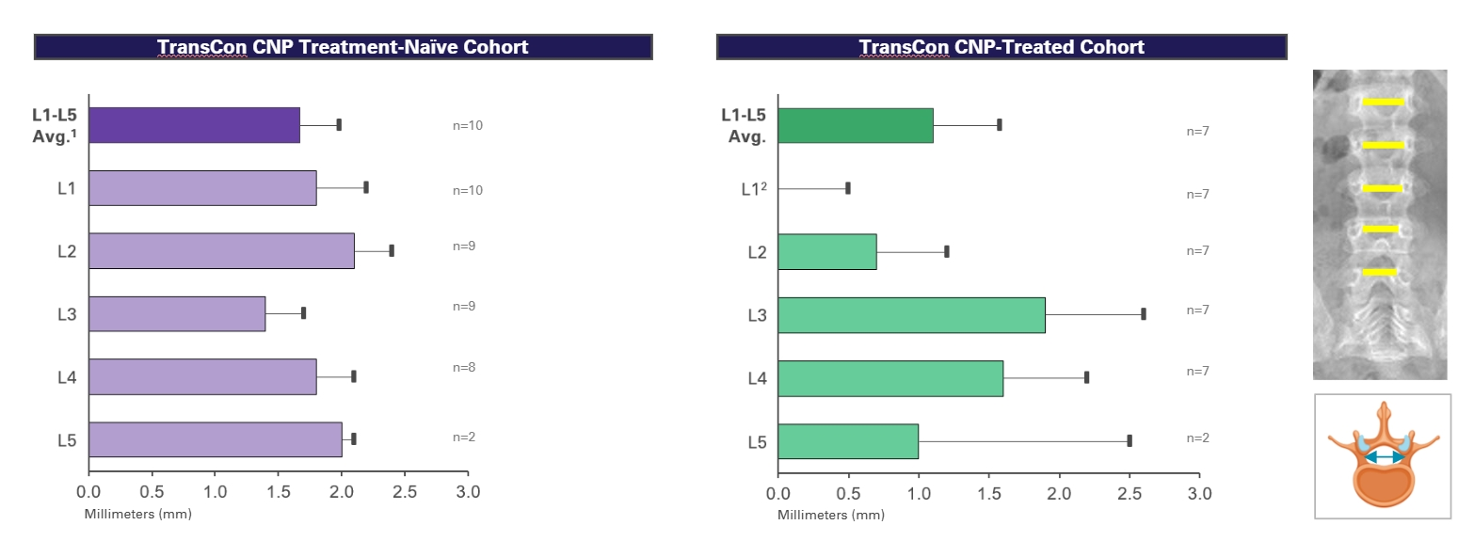
1Change from baseline to Week 52 for L1-L5 average for TransCon CNP group in the ApproaCH trial was +0.6 mm.
Mean of L1-L5 average changes in interpedicular distance (IPD) for TransCon CNP treatment-naïve and TransCon CNP-treated children on combination therapy in COACH were +1.7 mm and +1.1 mm, respectively, compared to +0.6 mm for children on TransCon CNP monotherapy in ApproaCH. Improvements in IPD offer the potential to reduce nerve compression and pain that can result from a narrowed spinal column.
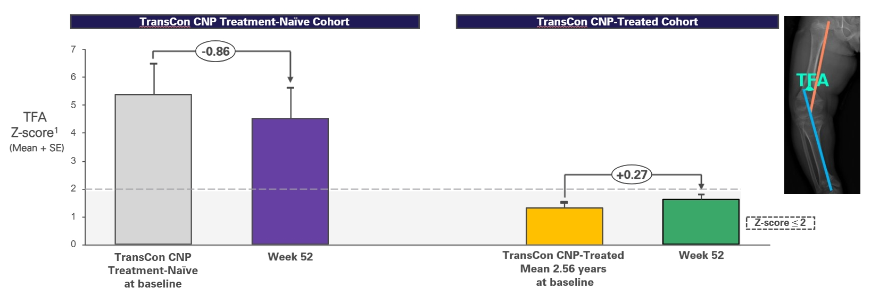
1Absolute Z-scores averaged across both legs, calculated based on data from children of average stature: Sabharwal S, Zhao C. The hip-knee-ankle angle in children: reference values based on a full-length standing radiograph. J Bone Joint Surg Am.2009 Oct;91(10):2461-8. doi: 10.2106/JBJS.I.00015.
For the TransCon CNP treatment-naïve cohort, the mean change in tibial femoral angle (TFA) Z-score was -0.86 with combination therapy at Week 52 in COACH and was -0.47 for TransCon CNP monotherapy at Week 52 in ApproaCH, indicating enhanced straightening of the legs. Children previously treated with long-term TransCon CNP monotherapy for an average of 2.56 years maintained in normal range for TFA Z-score.
22

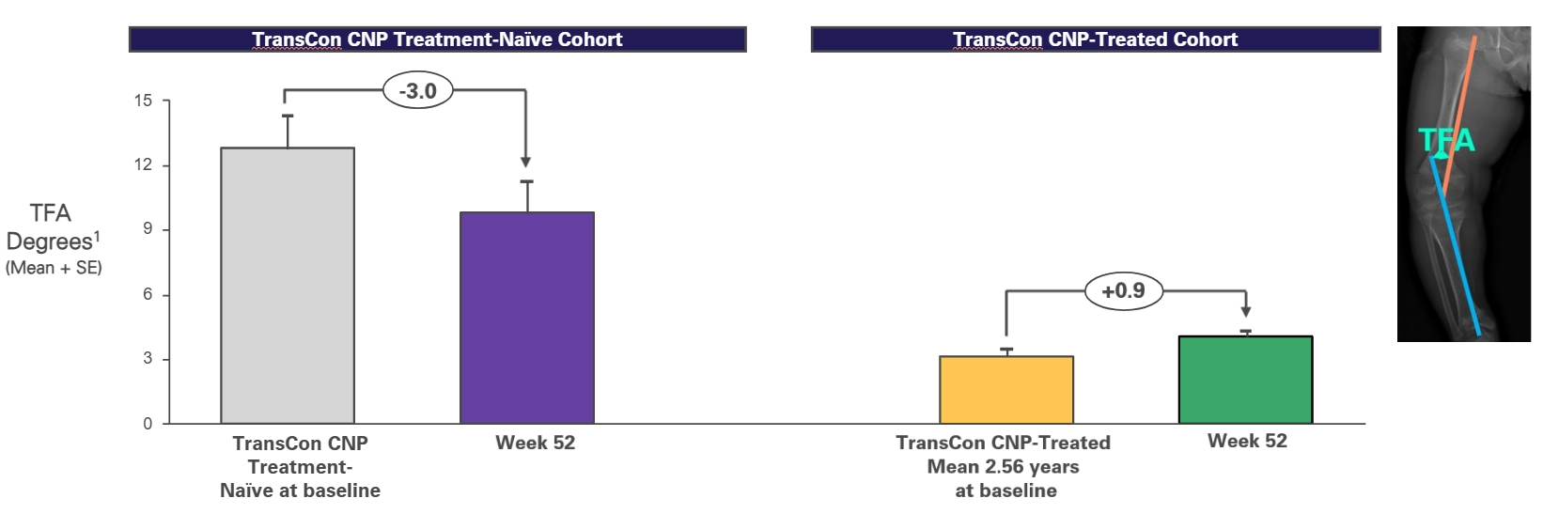
1Tibial femoral angles were determined for each leg and then converted to absolute values. Summary data are presented as the average absolute TFA across both legs.
For the TransCon CNP treatment-naïve cohort, the mean change in TFA was -3.0 degrees with combination therapy in COACH and was -1.3 degrees for children on TransCon CNP monotherapy at Week 52 in ApproaCH. Children previously treated with long-term TransCon CNP monotherapy for an average of 2.56 years maintained TFA treatment benefit in the setting of accelerated growth.
In January 2026, we announced topline results from Week 52 of COACH, the first Phase 2 clinical trial to evaluate combination therapy with once-weekly TransCon CNP (navepegritide) and once-weekly TransCon hGH (lonapegsomatropin) in children with achondroplasia. Annualized growth velocity exceeded the 97th percentile of average stature children and the improvement in achondroplasia-specific height Z-score indicated a tripling of efficacy compared to TransCon CNP monotherapy. Additionally, combination therapy demonstrated benefits beyond linear growth with improvements in body proportionality and arm span, aligning with the increase in linear growth. The combination therapy was generally well tolerated, with generally mild TEAEs, consistent with TransCon CNP and TransCon hGH monotherapies.
Strategic Collaborations and Investments
We also engage in strategic collaborations to further leverage our TransCon technologies in certain geographies and therapeutic areas with market-leading biopharmaceutical companies. These collaborations aim to make promising treatment options available to more patients and to further monetize both our TransCon technologies and our internal product candidates, particularly into therapeutic areas where we believe a partner may have more expertise, capability, and capital. In addition, we may choose to pursue a collaboration to develop and market our internal, wholly owned product candidates in geographic markets outside our core focus areas of the United States and Europe.
Novo Nordisk A/S
In November 2024, we entered into a research and development collaboration and license agreement with Novo Nordisk pursuant to which we granted Novo Nordisk an exclusive worldwide license to the TransCon technology platform to develop, manufacture and commercialize Novo Nordisk proprietary products (including Semaglutide) in metabolic diseases (including obesity and type 2 diabetes) and a product-by-product exclusive license in cardiovascular diseases.
The agreement includes provisions requiring at least one TransCon Semaglutide product and at least one other TransCon technology-based product to be identified, developed and commercialized in metabolic diseases to maintain certain exclusivities in the field, with additional provisions for cardiovascular diseases. Under the terms of the agreement, Novo Nordisk also receives exclusive rights to expand any resulting metabolic disease products into other therapeutic areas. The lead program in the collaboration is a once-monthly TransCon Semaglutide product candidate that will initially target obesity and type 2 diabetes.
23

Under the agreement, we have the potential to receive total payments of up to $285 million in upfront, development and regulatory milestone payments for the lead program. In addition, we have the potential to receive sales-based milestone payments and tiered royalties on global net sales. The $285 million includes an upfront fee of $100 million for the exclusive license that was paid to us in January 2025. For each additional metabolic or cardiovascular disease product candidate, we are eligible to receive payments of up to $77.5 million in development and regulatory milestone payments. Novo Nordisk agreed to pay royalties for each potential licensed product developed under the agreement that are an escalating tiered, mid-single digit percentage of the annual net sales of such licensed product and are subject to reduction due to patent valid claim expiration, biosimilar product market share, payment made under certain licenses for third party intellectual property and Inflation Reduction Act price negotiations.
Under the agreement, we have agreed to conduct certain pre-agreed early research and development of TransCon product candidates under the collaboration and we are eligible to receive cost reimbursement from Novo Nordisk for its performance of such research and development activities under the agreement with respect to such TransCon product candidates. Novo Nordisk is responsible for any other non-clinical and clinical development, regulatory, commercial manufacturing, and commercialization of such TransCon product candidates, and all costs associated with such activities.
Subject to the terms of the agreement, we granted Novo Nordisk an exclusive, worldwide, royalty-bearing license, with the right to grant sublicenses, to use our proprietary TransCon technology platform to develop, manufacture and commercialize Novo Nordisk proprietary products in metabolic diseases (including obesity and type 2 diabetes) and a product-by-product exclusive license in cardiovascular diseases. Additionally, we granted Novo Nordisk an exclusive, worldwide, royalty-bearing license, with the right to grant sublicenses, to use our proprietary TransCon technology platform to develop, manufacture and commercialize GLP-1 receptor products using the TransCon technology for all indications, except for (i) certain pre-agreed rare endocrine indications, (ii) all indications in respect of the eye and adnexa and (iii) all indications in respect of oncology.
Until expiry of the last royalty term and for one-year thereafter, we are not permitted to research, develop, manufacture, commercialize, or otherwise exploit outside of the collaboration, any GLP-1 receptor product or any other licensed products that have been subject to the collaboration. We are also not permitted to undertake any research, development, manufacture, commercialization, or other exploitation of products outside of the collaboration in the metabolic field until expiry of the last royalty term of any licensed products that have been subject to the collaboration in metabolic diseases.
Unless earlier terminated, the agreement has a royalty term that continues, on a per licensed product and per country basis, until the later of (i) the expiration of the last valid patent claim for any of our patents, joint improvement patents, licensed product patents as well as any improvements made by Novo Nordisk covering the licensed product’s dosage regimen or target product profile, or (ii) 11 years after the first commercial sale of such licensed product in such country.
Novo Nordisk has the right to terminate the agreement without cause in its entirety or on a per licensed product basis. We have the right to terminate the agreement in its entirety in case Novo Nordisk brings patent challenges with respect to our patents. The agreement may also be terminated by either party based on an uncured material breach by the other party or the bankruptcy of the other party.
Upon termination of the agreement due to Novo Nordisk’s default, some or all of the licenses granted by us to Novo Nordisk to develop, manufacture and commercialize any of the licensed products will automatically terminate.
Upon termination of the agreement due to certain defaults by us, Novo Nordisk may choose to either (i) have the license granted by us to Novo Nordisk to develop, manufacture and commercialize licensed products terminate in its entirety or on a product-by-product basis; or (ii) continue with respect to the affected licensed product at a reduced payment rate.
In January 2025, we announced that our multi-product collaboration with Novo Nordisk for TransCon technology-based therapies in obesity and metabolic diseases continues and that the lead program TransCon Semaglutide, remains on track to enter the clinic as anticipated.
Teijin Limited
In November 2023, we announced that we entered into an exclusive license agreement with Teijin for the further development and commercialization of TransCon hGH, TransCon PTH, and TransCon CNP for endocrinology rare disease in Japan. Under the terms of the agreement with Teijin, we received an upfront payment of $70 million, with additional development and regulatory milestones of up to $175 million, transfer pricing and commercial milestones. In addition, we are eligible to receive royalties on net sales in Japan, of up to a mid-20’s percentage, varying by product.
In February 2026, Teijin announced that it had applied for manufacturing and marketing approval in Japan for lonapegsomatropin for the treatment of pediatric GHD to the Pharmaceuticals and Medical Devices Agency.
24

In November 2025, Teijin announced that YORVIPATH is commercially available for prescription.
VISEN Pharmaceuticals
In November 2018, we announced the formation of VISEN, a company established to develop and commercialize our endocrinology rare disease therapies in Greater China. In connection with the formation of VISEN, we granted VISEN exclusive rights to develop and commercialize certain product candidates based on our proprietary TransCon technologies, including TransCon hGH, TransCon PTH, and TransCon CNP, in Greater China for use in all human indications, subject to certain exceptions. As consideration for the rights granted to VISEN, we received 50.0% ownership of the outstanding shares of VISEN and concurrently with the rights we granted to VISEN, entities affiliated with Vivo Capital and Sofinnova Ventures purchased shares in VISEN for an aggregate purchase price of $40 million in cash. In January 2021, we invested an additional $12.5 million in VISEN as part of VISEN’s $150 million Series B financing.
On March 20, 2025, VISEN announced the pricing of its initial public offering (“IPO”) on the Hong Kong Stock Exchange. The shares offered in the IPO were priced at HKD 68.80 per share and expected to result in gross proceeds of HKD 783,288,000 (approximately USD 100 million) plus a potential greenshoe of up to HKD 117,489,760 (approximately USD 15 million). This amount was calculated before deducting underwriting discounts, commissions, and other offering expenses. The IPO closed on March 21, 2025, and VISEN’s shares began trading under the stock code 2561.HK. Ascendis Pharma holds 41,136,364 shares in VISEN. Following the IPO, we owned 39.2% in VISEN. The management and existing shareholders of VISEN, including Ascendis Pharma, have entered into customary lock-up agreements restricting the sale of VISEN shares for six months following the IPO; additionally, certain significant shareholders of VISEN, including Ascendis Pharma, are subject to an additional lock-up obligation during the period commencing on the date that is six months after the IPO and ending on the date that is 12 months after the IPO during which such shareholders may not sell shares of VISEN to an extent that would cause such shareholder to cease being a controlling shareholder of VISEN pursuant to applicable listing rules. As of December 31, 2025 and 2024, our ownership in VISEN was 39.2% and 43.9%, respectively. As of December 31, 2025, VISEN’s share price at the Hong Kong Stock Exchange was HK$32.80, reflecting the market value of the our equity position of €147.5 million.
In July 2026, VISEN announced the commercial launch of lonapegsomatropin (TransCon hGH) in Mainland China.
In April 2026, VISEN announced that results from its briGHt Trial, the pivotal Phase 3 trial in China of once-weekly lonapegsomatropin (TransCon hGH) in pediatric patients with GHD, were published in Hormone Research in Paediatrics, the official journal of the European Society for Paediatric Endocrinology (“ESPE”). The briGHt Trial was a Phase 3, randomized, open-label, active-controlled trial conducted across 17 sites in China. VISEN reported that weekly lonapegsomatropin demonstrated non-inferiority and superiority over daily somatropin in annualized height velocity (“AHV”) among treatment-naïve Chinese children with GHD.
In January 2026, VISEN announced its biologics license application (“BLA”) for lonapegsomatropin (TransCon hGH) was approved by the National Medical Products Administration (“NMPA”) of China for the treatment of pediatric patients who have growth failure due to inadequate secretion of growth hormone in China.
In September 2025, VISEN announced that palopegteriparatide (TransCon PTH) was approved by the Hainan Medical Products Administration for clinical use in the Boao Lecheng Pilot Zone for the treatment of adults with chronic hypoparathyroidism.
In August 2024, VISEN announced top-line data from the 26-week randomized, double-blind, placebo-controlled portion of the Phase 3 PaTHway China Trial of Palopegteriparatide (TransCon PTH) in adults with chronic hypoparathyroidism. VISEN reported a statistically significant higher proportion of patients treated with palopegteriparatide achieved the primary multi-component endpoint compared to placebo. The primary multi-component endpoint was achieved by 77.6% of palopegteriparatide-treated patients (45 of 58), compared to 0.0% of patients (0 of 22) in the placebo group (p-value <0.0001). Results were consistent with those announced by us for our palopegteriparatide Phase 3 trial.
In November 2023, VISEN announced top-line results from the Phase 2 ACcomplisH China Trial in children with achondroplasia aged 2 to 10 years. VISEN reported that patients dosed with TransCon CNP at the 100 μg CNP/kg/week showed significantly higher AGV than placebo at Week 52.
In November 2022, VISEN announced data from its pivotal Phase 3 study of TransCon hGH in children with GHD in China. VISEN reported that patients dosed with TransCon hGH demonstrated an AHV of 10.66 cm/year compared to 9.75 cm/year for daily hGH at 52 weeks (treatment difference at 0.91 cm/year with a 95% confidence interval: 0.37 – 1.45 cm/year, p=0.0010), reaching its primary objective, demonstrating that TransCon hGH is non-inferior to the daily hGH.
25

Market Opportunity in China
China is the second largest pharmaceutical market in the world after the United States and represents one of the fastest growing pharmaceutical markets worldwide. In recent years, the Chinese government has initiated a number of regulatory reforms that are expected to accelerate drug development, as well as drive growth and demand for new therapeutics in China. In addition to joining an international organization that standardizes regulations for clinical development, the NMPA has introduced initiatives such as fast track review for drugs for unmet medical needs and adopted new rules that streamline the drug approval process in China for global companies.
The purpose of our investment in VISEN is to support our strategy to extend our endocrinology rare disease portfolio globally and establish a presence in China in partnership with collaborators who have significant experience and knowledge of the biopharmaceutical opportunity in China.
Rights Agreements
Under three exclusive license agreements, each effective November 7, 2018, and as amended January 4, 2021, between us and VISEN (collectively, the “Rights Agreements”), VISEN must use diligent efforts to develop and commercialize licensed products in Greater China. Additionally, we and VISEN will conduct certain research and development activities allocated to the respective party under a research and technical development plan, and VISEN will reimburse us for costs of conducting such activities, including costs of our personnel committed to performing such activities in Greater China.
We entered into a clinical supply agreement with VISEN in 2018 to provide product supply for use in conducting clinical trials in Greater China. Additionally, during 2023, we entered into a commercial supply agreement governing commercial supply of licensed product (TransCon hGH) to VISEN on the terms and conditions set forth in the Rights Agreements. Further, in June 2025, we entered into a Commercial Supply Framework Agreement with VISEN regarding the supply of additional batches of licensed product (TransCon hGH) to VISEN.
Under the Rights Agreements, we agreed not to research, develop, or commercialize competing products in Greater China, and VISEN agreed not to grant certain rights under its interest in any inventions or intellectual property arising out of the activities conducted under the Rights Agreements to third-parties, in each case, under the terms and conditions specified in the Rights Agreements. We will have the right to exploit inventions and intellectual property arising out of the activities conducted under the Rights Agreements outside of Greater China. Additionally, we granted VISEN a right of first negotiation to develop and commercialize certain of our endocrinology products in Greater China.
The Rights Agreements continue in effect for as long as a valid claim of a licensed patent exists in Greater China. VISEN may terminate a Rights Agreement for convenience, for uncured material breach by us of a Rights Agreement and for our bankruptcy or insolvency-related events. We may terminate a Rights Agreement for certain specified material breaches thereof by VISEN, in the event VISEN undergoes a change of control in favor of a competitor, if VISEN challenges the validity of any of the licensed patents and for VISEN’s bankruptcy or insolvency-related events.
Eyconis, Inc.
In January 2024, we announced the formation and launch with Frazier Life Sciences of Eyconis Inc., a separate company created to develop, manufacture, and commercialize TransCon ophthalmology assets globally, together with a $150 million commitment from an investor syndicate that included Frazier, RA Capital Management, venBio, and HealthQuest Capital. We have granted Eyconis exclusive rights to develop and commercialize TransCon ophthalmology products globally and received an equity position in the newly formed company. In addition, we are eligible to receive development, regulatory, and sales milestone payments, plus single digit royalties on global net sales of commercialized products, if any. As of June 30, 2026, our ownership in Eyconis was 24% on a non-diluted basis.
26

Results of Operations
Financial Highlights (unaudited)
 |  | Three Months Ended  June 30, |  |  |  |  |  |  |  |  |  |  |  | Six Months Ended  June 30,
(EUR’000) |  | 2026 |  |  |  | 2025 |  |  |  | Change |  |  |  | 2026 |  |  |  | 2025 |  |  |  | Change
Revenue |  |  | 339,285 |  |  |  | 158,045 |  |  |  | 181,240 |  |  |  | 585,886 |  |  |  | 258,998 |  |  |  | 326,888
Gross profit |  |  | 311,627 |  |  |  | 126,598 |  |  |  | 185,029 |  |  |  | 540,713 |  |  |  | 210,035 |  |  |  | 330,678
Operating expenses (1) |  |  | 249,229 |  |  |  | 179,549 |  |  |  | 69,680 |  |  |  | 453,503 |  |  |  | 367,199 |  |  |  | 86,304
Operating profit/(loss) |  |  | 220,465 |  |  |  | (52,951 | ) |  |  | 273,416 |  |  |  | 245,277 |  |  |  | (157,164 | ) |  |  | 402,441
Net profit/(loss) for the period |  |  | 206,970 |  |  |  | (38,855 | ) |  |  | 245,825 |  |  |  | 836,310 |  |  |  | (133,482 | ) |  |  | 969,792
Cash flows from/(used in) operating activities |  |  | 281,682 |  |  |  | (7,342 | ) |  |  | 289,024 |  |  |  | 273,961 |  |  |  | (21,654 | ) |  |  | 295,615
(1)
Operating expenses comprise research and development expenses and selling, general and administrative expenses.
Compared to the three and six months ended June 30, 2025, revenue for the three and six months ended June 30, 2026, primarily benefited from the continued growth of YORVIPATH global sales. Operating profit for the three and six months ended June 30, 2026, represented an improvement of €273.4 million and €402.4 million compared to the same period last year. This improvement reflected higher revenue, sale of the Rare Pediatric Disease Priority Review Voucher (“PRV”), partially offset by higher operating expenses associated with commercial expansion.
Net profit for the six months ended June 30, 2026 was €836.3 million, compared to a net loss of €133.5 million for the same period last year. In addition to the positive development in operating profit, this development was driven by initial recognition of deferred tax assets of €679.6 million in the first quarter of 2026, partly offset by higher net financial expenses of €63.1 million, compared to the same period last year, primarily related to non-cash items.
Cash flows from operating activities for the six months ended June 30, 2026, represented an improvement of €295.6 million compared to the same period last year, primarily attributable to commercial revenue growth and net proceeds from sale of the PRV, partially offset by unfavorable changes to working capital.
Foreign currency translation reduced reported revenue for the three and six months ended June 30, 2026 by €7.6 million and €28.0 million, compared to the same period last year. Similarly, operating expenses decreased due to currency translation by €2.9 million and €16.3 million for the three and six months ended June 30, 2026, compared to the same period last year.
Total equity presented a surplus of €1,436.5 million as of June 30, 2026, compared to a deficit of €162.8 million as of December 31, 2025. In addition to net profit, this improvement includes the redemption of $575 million of outstanding 2.25% convertible notes on May 6, 2026. The conversion resulted in the settlement of the current liabilities of convertible notes to equity, comprising borrowings and derivative liabilities totaling €719.4 million as of the redemption date. The conversion had no impact on profit or loss.
Further details about our results of operations and cash flows are described in the following sections.
Comparison of the Three and Six Months Ended June 30, 2026 and 2025 (unaudited)
Revenue
The following table summarizes our revenue for the three and six months ended June 30, 2026 and 2025:
 |  | Three Months Ended  June 30, |  |  |  |  |  |  |  |  |  |  |  | Six Months Ended  June 30,
(EUR’000) |  | 2026 |  |  |  | 2025 |  |  |  | Change |  |  |  | 2026 |  |  |  | 2025 |  |  |  | Change
Revenue
Commercial products |  |  | 314,910 |  |  |  | 153,663 |  |  |  | 161,247 |  |  |  | 555,763 |  |  |  | 249,690 |  |  |  | 306,073
Services and clinical supply |  |  | 4,856 |  |  |  | 3,570 |  |  |  | 1,286 |  |  |  | 9,965 |  |  |  | 7,094 |  |  |  | 2,871
Licenses |  |  | 2,473 |  |  |  | 812 |  |  |  | 1,661 |  |  |  | 3,112 |  |  |  | 2,214 |  |  |  | 898
Milestones |  |  | 17,046 |  |  |  | — |  |  |  | 17,046 |  |  |  | 17,046 |  |  |  | — |  |  |  | 17,046
Total revenue |  |  | 339,285 |  |  |  | 158,045 |  |  |  | 181,240 |  |  |  | 585,886 |  |  |  | 258,998 |  |  |  | 326,888

27

Revenue from sale of commercial products was as follows:
 |  | Three Months Ended  June 30, |  |  |  |  |  |  |  |  |  |  |  | Six Months Ended  June 30,
(EUR’000) |  | 2026 |  |  |  | 2025 |  |  |  | Change |  |  |  | 2026 |  |  |  | 2025 |  |  |  | Change
Revenue from commercial products
YORVIPATH® |  |  | 252,114 |  |  |  | 102,957 |  |  |  | 149,157 |  |  |  | 449,010 |  |  |  | 147,646 |  |  |  | 301,364
SKYTROFA® |  |  | 55,214 |  |  |  | 50,706 |  |  |  | 4,508 |  |  |  | 99,171 |  |  |  | 102,044 |  |  |  | (2,873 | )
YUVIWEL® |  |  | 7,582 |  |  |  | — |  |  |  | 7,582 |  |  |  | 7,582 |  |  |  | — |  |  |  | 7,582
Total revenue from commercial products |  |  | 314,910 |  |  |  | 153,663 |  |  |  | 161,247 |  |  |  | 555,763 |  |  |  | 249,690 |  |  |  | 306,073
Revenue from sales of commercial products for the three and six months ended June 30, 2026 represented an increase of €161.2 million and €306.1 million, respectively, compared to the same period last year, primarily due to the continued growth of YORVIPATH global sales. In addition, revenue was positively impacted by the U.S. launch of YUVIWEL.
Revenue from sales of SKYTROFA was impacted by increased revenue in the U.S. offset by lower collaboration revenue.
Cost of Sales
Cost of sales for the three and six months ended June 30, 2026 was €27.7 million and €45.2 million, respectively, representing a decrease of €3.8 million compared to the same period last year. This development was primarily due to increased revenue in the U.S. offset by lower collaboration revenue.
Research and Development Expenses
The following table specifies external project costs on the development pipeline and other research and development (“R&D”) expenses.
 |  | Three Months Ended  June 30, |  |  |  |  |  |  |  |  |  |  |  | Six Months Ended  June 30,
(EUR’000) |  | 2026 |  |  |  | 2025 |  |  |  | Change |  |  |  | 2026 |  |  |  | 2025 |  |  |  | Change
External project costs
Hypoparathyroidism |  |  | 3,699 |  |  |  | 2,195 |  |  |  | 1,504 |  |  |  | 6,392 |  |  |  | 8,518 |  |  |  | (2,126 | )
Growth Disorders |  |  | 24,506 |  |  |  | 18,690 |  |  |  | 5,816 |  |  |  | 34,608 |  |  |  | 36,386 |  |  |  | (1,778 | )
Oncology |  |  | 2,622 |  |  |  | 9,499 |  |  |  | (6,877 | ) |  |  | 4,557 |  |  |  | 21,251 |  |  |  | (16,694 | )
Other project costs |  |  | 1,187 |  |  |  | 255 |  |  |  | 932 |  |  |  | 1,915 |  |  |  | 1,337 |  |  |  | 578
Total external project costs |  |  | 32,014 |  |  |  | 30,639 |  |  |  | 1,375 |  |  |  | 47,472 |  |  |  | 67,492 |  |  |  | (20,020 | )
Other research and development expenses
Employee costs |  |  | 36,935 |  |  |  | 36,776 |  |  |  | 159 |  |  |  | 74,200 |  |  |  | 74,719 |  |  |  | (519 | )
Other costs |  |  | 4,489 |  |  |  | 2,572 |  |  |  | 1,917 |  |  |  | 8,464 |  |  |  | 8,169 |  |  |  | 295
Depreciation |  |  | 2,450 |  |  |  | 2,001 |  |  |  | 449 |  |  |  | 4,796 |  |  |  | 4,157 |  |  |  | 639
Impairment |  |  | — |  |  |  | — |  |  |  | — |  |  |  | — |  |  |  | 4,054 |  |  |  | (4,054 | )
Total other research and development expenses |  |  | 43,874 |  |  |  | 41,349 |  |  |  | 2,525 |  |  |  | 87,460 |  |  |  | 91,099 |  |  |  | (3,639 | )
Total research and development expenses |  |  | 75,888 |  |  |  | 71,988 |  |  |  | 3,900 |  |  |  | 134,932 |  |  |  | 158,591 |  |  |  | (23,659 | )
R&D expenses for the three and six months ended June 30, 2026 were €75.9 million and €134.9 million, representing an increase of €3.9 million and a decrease of €23.7 million, respectively, compared to the same period last year. This development was primarily due to increased clinical trial activities within the Endocrinology Rare Disease pipeline, offset by reduced clinical trial activities within Oncology. Further, the six months ended June 30, 2026 included a reversal (income) of prior period write-downs related to pre-launch inventories for Growth Disorders of €10.9 million due to the U.S. FDA approval of YUVIWEL.
28

Selling, General and Administrative Expenses
The following table specifies selling, general and administrative (“SG&A”) expenses:
 |  | Three Months Ended  June 30, |  |  |  |  |  |  |  |  |  |  |  | Six Months Ended  June 30,
(EUR’000) |  | 2026 |  |  |  | 2025 |  |  |  | Change |  |  |  | 2026 |  |  |  | 2025 |  |  |  | Change
Selling, general, and administrative expenses
Employee costs |  |  | 64,432 |  |  |  | 50,897 |  |  |  | 13,535 |  |  |  | 126,675 |  |  |  | 101,217 |  |  |  | 25,458
Other costs |  |  | 107,246 |  |  |  | 54,813 |  |  |  | 52,433 |  |  |  | 188,819 |  |  |  | 100,142 |  |  |  | 88,677
Depreciation |  |  | 1,663 |  |  |  | 1,851 |  |  |  | (188 | ) |  |  | 3,077 |  |  |  | 3,795 |  |  |  | (718 | )
Impairment |  |  | — |  |  |  | — |  |  |  | — |  |  |  | — |  |  |  | 3,454 |  |  |  | (3,454 | )
Total selling, general, and administrative expenses |  |  | 173,341 |  |  |  | 107,561 |  |  |  | 65,780 |  |  |  | 318,571 |  |  |  | 208,608 |  |  |  | 109,963
SG&A expenses for the three and six months ended June 30, 2026 were €173.3 million and €318.6 million, representing an increase of €65.8 million and €110.0 million, respectively, compared to the same period last year. This increase was primarily due to the continued impact from commercial expansion, including global launch activities.
Finance Income and Expenses
The following table specifies the result of finance income and expenses, further disaggregated into cash and non-cash items:
 |  | Three Months Ended  June 30, |  |  |  |  |  |  |  |  |  |  |  | Six Months Ended  June 30,
(EUR’000) |  | 2026 |  |  |  | 2025 |  |  |  | Change |  |  |  | 2026 |  |  |  | 2025 |  |  |  | Change
Net finance income/(expenses)
Finance income |  |  | 19,965 |  |  |  | 55,059 |  |  |  | (35,094 | ) |  |  | 9,347 |  |  |  | 83,912 |  |  |  | (74,565 | )
Finance expenses |  |  | (14,173 | ) |  |  | (33,018 | ) |  |  | 18,845 |  |  |  | (66,292 | ) |  |  | (77,803 | ) |  |  | 11,511
Total net finance income/(expenses) |  |  | 5,792 |  |  |  | 22,041 |  |  |  | (16,249 | ) |  |  | (56,945 | ) |  |  | 6,109 |  |  |  | (63,054 | )
Specified in cash and non-cash items
Cash items
Finance income received |  |  | 4,829 |  |  |  | 3,395 |  |  |  | 1,434 |  |  |  | 9,347 |  |  |  | 7,603 |  |  |  | 1,744
Finance expenses paid |  |  | (11,786 | ) |  |  | (8,735 | ) |  |  | (3,051 | ) |  |  | (17,115 | ) |  |  | (9,689 | ) |  |  | (7,426 | )
Non-cash items
Remeasurement gain/(loss) of financial liabilities |  |  | 8,313 |  |  |  | (10,599 | ) |  |  | 18,912 |  |  |  | (25,938 | ) |  |  | (34,510 | ) |  |  | 8,572
Currency gain/(loss) |  |  | 6,823 |  |  |  | 48,759 |  |  |  | (41,936 | ) |  |  | (5,429 | ) |  |  | 73,404 |  |  |  | (78,833 | )
Amortization charges, accruals, and other items |  |  | (2,387 | ) |  |  | (10,779 | ) |  |  | 8,392 |  |  |  | (17,810 | ) |  |  | (30,699 | ) |  |  | 12,889
Total net finance income/(expenses) |  |  | 5,792 |  |  |  | 22,041 |  |  |  | (16,249 | ) |  |  | (56,945 | ) |  |  | 6,109 |  |  |  | (63,054 | )
Interest expenses measured under the effective interest method, related to:
Convertible senior notes |  |  | (2,444 | ) |  |  | (8,931 | ) |  |  | 6,487 |  |  |  | (11,627 | ) |  |  | (18,583 | ) |  |  | 6,956
Royalty funding liabilities |  |  | (9,992 | ) |  |  | (9,708 | ) |  |  | (284 | ) |  |  | (19,833 | ) |  |  | (19,983 | ) |  |  | 150
Lease liabilities |  |  | (1,728 | ) |  |  | (872 | ) |  |  | (856 | ) |  |  | (3,455 | ) |  |  | (1,697 | ) |  |  | (1,758 | )
The development in non-cash items was primarily driven by remeasurement loss of financial liabilities, and net currency gains, primarily driven by conversion of U.S. dollar denominated monetary positions into Euro, primarily cash and cash equivalents, convertible notes and royalty funding liabilities. In addition, interest expenses were lower due to the redemption of all of the aggregate principal amount outstanding of our convertible notes on May 6, 2026. Refer to Note 11, “Financial Assets and Liabilities” for further information about our convertible notes and royalty funding agreements.
Income Taxes
For the six months ended June 30, 2026, net income tax benefit through the profit or loss was €654.4 million, primarily reflecting €679.6 million from the reversal of prior-period write-downs against deferred tax assets, recognized in the first quarter of 2026.
29

Liquidity and Capital Resources
Our liquidity and capital resources comprise cash and cash equivalents, which as of June 30, 2026, amounted to €812.3 million.
Our expenditures primarily relate to research and development activities and selling, general, and administrative activities to support our business, including our continued development of products and product candidates, the commercialization of our products, and expenses incurred in anticipation of potential future product launches. We manage our liquidity risk by maintaining adequate cash reserves. The risk of shortage of funds is monitored, through the financial forecasting process, to ensure sufficient funds are available to settle liabilities as they fall due.
Historically, we have funded our operations primarily through the issuance of preference shares, ordinary shares (including public offerings and exercise of warrants), convertible debt securities, payments to us made under collaboration agreements, and our royalty funding agreements. Including our initial public offering, since February 2015, we have completed public offerings that have provided aggregate net proceeds of $2,580.2 million (or €2,259.0 million at the time of the public offerings).
On May 6, 2026, the Company completed its previously announced optional redemption process in respect of all of the aggregate principal amount outstanding of its 2.25% convertible notes due 2028. Within the redemption period, all holders of the convertible notes surrendered their notes for conversion, whereupon the Company delivered 3,635,813 ordinary shares (following the exchange of all outstanding ADSs for ordinary shares on April 20, 2026), together with cash in lieu of fractional shares. Refer to Note 11, “Financial Assets and Liabilities” for further information about our convertible notes and royalty funding agreements.
For additional description of our cash requirements, public offerings, expense structure and commitments, refer to “Item 5B. Liquidity and Capital Resources,” set forth in our Annual Report on Form 20-F filed with the Securities and Exchange Commission on February 11, 2026.
Based on our current operating plan, we currently estimate that our existing cash and cash equivalents will be sufficient to fund our operations for at least twelve months from the date of this report. However, our operating plan and actual cash requirements may change as a result of many factors. For example, our future funding requirements will depend on many factors, including, but not limited to those described in “Item 3.D – Key Information—Risk Factors—Risks Related to Our Limited Operating History, Financial Condition and Capital Requirements,” set forth in our Annual Report on Form 20-F filed with the Securities and Exchange Commission on February 11, 2026.
30

The following table summarizes our cash flows for the six months ended June 30, 2026 and 2025:
Six Months Ended
June 30,
(EUR’000) |  | 2026 |  |  |  | 2025 |  |  |  | Change
Cash flows from/(used in)
Operating activities |  |  | 273,961 |  |  |  | (21,654 | ) |  |  | 295,615
Investing activities |  |  | (9,607 | ) |  |  | (5,041 | ) |  |  | (4,566 | )
Financing activities |  |  | (82,952 | ) |  |  | (11,043 | ) |  |  | (71,909 | )
Net increase/(decrease) in cash and cash equivalents |  |  | 181,402 |  |  |  | (37,738 | ) |  |  | 219,140
Cash Flows from/(used in) Operating Activities
Cash flows from operating activities for the six months ended June 30, 2026, were €274.0 million, representing an improvement of €295.6 million compared to the same period last year, primarily related to commercial revenue growth, and sale of the PRV of €158.1 million (net of transaction costs), partially offset by unfavorable changes to working capital of €95.8 million which primarily related to the settlement of the upfront payment from our exclusive license agreement with Novo Nordisk of $100 million plus related indirect taxes in 2025.
Cash Flows from/(used in) Investing Activities
Cash flows used in investing activities for the six months ended June 30, 2026, were €9.6 million, representing an increase of €4.6 million compared to the same period last year and was primarily attributable to leasehold improvements.
Cash Flows from/(used in) Financing Activities
Cash flows used in financing activities for the six months ended June 30, 2026 were €83.0 million, representing an increase of €71.9 million compared to the same period last year, primarily reflecting €86.0 million higher treasury shares repurchases, partly offset by €23.8 million higher proceeds from warrant exercises.
Off-Balance Sheet Arrangements
We have not entered into any off-balance sheet arrangements and we do not have any holdings in variable interest entities.
Qualitative Disclosures about Market Risk
Our activities expose us to financial risks of changes in foreign currency exchange rates, inflation rates and interest rates. We do not enter into derivative financial instruments to manage our exposure to such risks. Further, we are exposed to credit risk, equity risk and liquidity risk. For a description of our exposure to liquidity risks, including risks associated with the royalty funding liabilities and processes for managing these risks, please refer to “Liquidity and Capital Resources,” set forth above, and maturity analysis for non-derivative financial liabilities provided in Note 11, “Financial Assets and Liabilities.”
Foreign Currency Risk
We are exposed to foreign exchange risk arising from various currency exposures, primarily with respect to the U.S. Dollar. While our reporting currency is the Euro, a substantial portion of our revenue and operating expenses is denominated in U.S. Dollars. In addition, our royalty funding liabilities are denominated in U.S. Dollars. We seek to minimize exchange rate risk by holding cash in the same currencies as our liabilities and expected future cash outflows.
Interest Rate Risk
Our indebtedness relates to royalty funding liabilities and lease liabilities. The interest rate on lease liabilities is fixed at the lease commencement date. Expected maturity for royalty funding liabilities is based on anticipated amount and timing of future revenue from sale of commercial products, and accordingly is not affected by changes in interest rates.
On May 6, 2026, we completed our previously announced optional redemption process in respect of all of the aggregate principal amount outstanding of our 2.25% convertible notes due 2028. Within the redemption period, all holders of the convertible notes surrendered their notes for conversion, whereupon we delivered 3,635,813 ordinary shares, together with cash in lieu of fractional shares.
The conversion resulted in the settlement of the current liabilities of convertible notes to equity, comprising borrowings and derivative liabilities totaling €719.4 million as of May 6, 2026. The conversion had no impact on profit or loss.
31

Credit Risk
We have adopted an investment policy with the primary purpose of preserving capital, fulfilling our liquidity needs and diversifying the risks associated with cash, cash equivalents and marketable securities. Our investment policy establishes minimum ratings for institutions with which we hold cash, cash equivalents and marketable securities, as well as rating and concentration limits for marketable securities held. All material counterparties are considered creditworthy. While the concentration of credit risk may be significant, the credit risk for each counterparty is considered to be low. Our exposure to credit risk primarily relates to cash and cash equivalents. The credit risk on our bank deposits is limited because the counterparties holding significant deposits are banks with high credit-ratings (minimum A3/A-) assigned by international credit-rating agencies.
We maintain the majority of our cash and cash equivalents in accounts with major financial institutions, and our deposits at these institutions exceed insured limits. Market conditions can impact the viability of these institutions. In the event of failure of any of the financial institutions where we maintain our cash and cash equivalents, there can be no assurance that we would be able to access uninsured funds in a timely manner or at all. Any inability to access or delay in accessing these funds could adversely affect our business and financial position. The banks are reviewed on a regular basis and deposits may be transferred during the year to mitigate credit risk.
In order to mitigate the concentration of credit risks on bank deposits and to preserve capital, a portion of the bank deposits may be placed into marketable securities. Our investment policy, approved by the Board, only allows investment in marketable securities having investment grade credit-ratings, assigned by international credit-rating agencies. As of June 30, 2026, we do not hold marketable securities.
On each reporting date, we consider the risk of expected credit loss on bank deposits and marketable securities, if any, including the hypothetical impact arising from the probability of default, which is considered in conjunction with the expected loss caused by default by banks or securities with similar credit-ratings and attributes. In line with previous periods, this assessment did not reveal a material impairment loss, and accordingly no provision for expected credit loss has been recognized.
32

